

2026 JUNIOR HIGH SCHOOL
ULTIMATE CHAMPIONSHIPS
YEARS: 7-10

FRIDAY 31ST OCTOBER

MURDOCH UNIVERSITY SPORTS OVAL

INFORMATION PACK



Event Details:
Date: Friday 31st October
Time: 9:30am - 2:00pm (first game starting at 10:00am)
Location: Dianella Regional Open Space
Cost: $50.00 entry fee per team

Registrations
Registration closes at 5pm on Wednesday the 21st of October 2026, Schools are eligible to enter mixed-gender teams for each year group. Registration forms are attached.
Team Numbers and Rosters
There are 6 players on a field at a time, you may have as many substitutes as you wish on the team. In the Mixed-Gender Division Format, there will be a 3/3 gender split of either gender on the field at all times. There is a MAXIMUM of 3 of any gender on the field at any time. We recommend a team of 8-10 players to allow for substitutes as you will be playing multiple games throughout the day. The only exception may be injuries or illness during the day where if both teams agree and speak to the Tournament Director an alternate option may be possible.
This event will be open to all High Schools and will offer the following divisions and age groups:
MIXED DIVISION | Year 7 | Year 8
 | Year 9 | Year 10
 | Year 7-8 Combined | Year 9-10 Combined
Combination teams are permissible, depending on the ratio we will assess and fairly assign combination teams to the applicable division. Divisions can also be renamed to align with registrations received.
*The minimum number of team registrations required for a division to go ahead is four (4). WA Ultimate holds the right to cancel, amend or rename a division if there are not enough participating teams registered in that division. If you have entered a team in a division that does become cancelled, you will be notified prior to the event and may enter the participants in another division.
Lunch and Food Services:
There will be water facilities available to fill water bottles and stay hydrated throughout the day. There will be food for purchase on the day including a sausage sizzle, snacks and cold drinks. Only Cash and PayId will be accepted, there are no credit card services available. Murdoch University does have a Food Precinct but it is NOT close to the fields.

Equipment:
Discs: Official game discs: 175g Ultra-Star will be in use for the Junior High School Ultimate Championships.
Uniforms: Teams are encouraged to wear a matching school or sports uniform for the event, bibs will be accessible if necessary when a school has multiple teams and has to play against themselves.
Footwear: Ultimate is generally played in cleats (eg. Football/soccer boots.) This footwear helps with turning and pivoting in the game of Ultimate. Cleats are not necessary or mandatory to play, however, enclosed shoes (running shoes) are.

NOTE: All equipment for games will be provided. If any discs or equipment is borrowed, please ensure it is returned at the end of the day.
Location
The event is being held at Murdoch University Sports Oval, Wagtail Close, Murdoch.

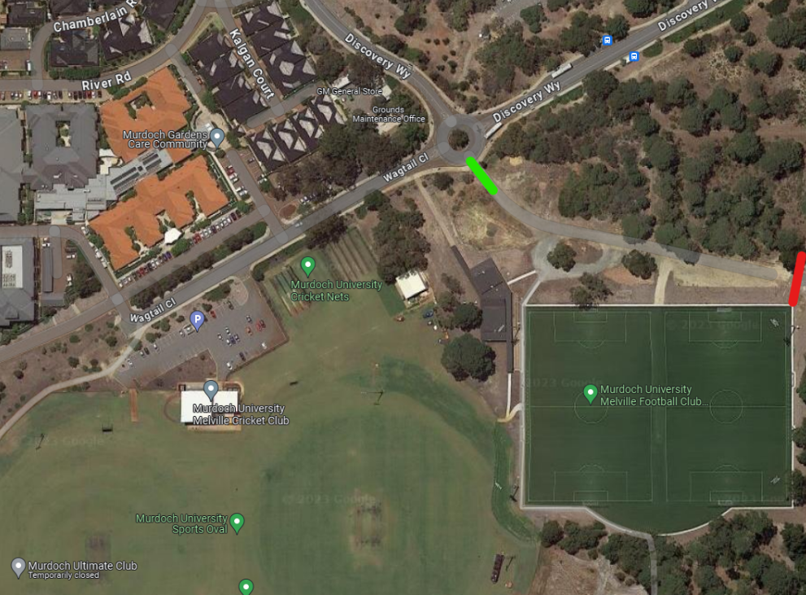

Transport and Parking:
The car park is accessible for buses, and is located alongside the playing fields, it is marked by the Purple P in the above picture. Schools may park their bus in this car park for the day’s duration or arrange a bus service to pick up/drop off from the car park located on-site. There is plenty of parking available.

Spectators:
Spectators are more than welcome to attend this event in support of their school and children. They will also be able to park in the space provided. We suggest spectators bring their own chairs and practice a sun smart attitude.

Rules:
The 2026 Junior High School Ultimate Championships will be using a set of Modified rules, these rules have been provided in the email.
Ultimate is based on Spirit of the Game (SOTG). That places the responsibility for fair play on every player. There are no external referees; the players are solely responsible for following and enforcing the rules, even at the World Championship level. Competitive play is encouraged, but never at the expense of respect between players, adherence to the rules, and the basic joy of play. To help participants learn this unique aspect of the game we will provide Game Facilitators at each field to help fairly regulate games.

There are 6 players on a field at a time, you may have as many substitutes as you wish on the team. Substitutes may only be made once a point has finished, or in the case of an injury.

When starting a game the opposing captains will have to “flip” the disc, similar to a coin toss. The winner of this disc flip will then proceed to choose either; to start on offence/defence OR to start at a particular end. The loser of the disc flip will then choose the other of the options.

Game Facilitators
We will provide Game Facilitators at each field. These Facilitators will be there to clarify rules, keep the games running smoothly, assist with Spirit of the Game and provide ongoing support to all teams taking part in the event. It is likely that some Game Facilitators will be overseeing more than one field and hence the Spirit of the Game and unbiased assistance from teachers and support staff is also an important factor.

Schedules, Games and Formats:
Game schedules and fixtures will be confirmed at a later date once team registrations have closed and participant numbers confirmed.

Tournament Central:
Tournament Central (TC) will be set up at the main clubroom allowing for easy access from all areas.
TC will be for all your needs including maps, schedules, fixtures, results, score reporting, First Aid, hand sanitiser and sunscreen.
Any questions you have or anything you need can be directed to and answered at Tournament Central with our WA Ultimate Volunteers.

Seeking shade:
WA Ultimate will provide shade tents set up around the venue, beside the playing fields. Schools may bring their own shade tent with them if they wish, which may be set up around the perimeter of the playing fields to provide a hub for the respective schools.

Medical:
First Aid and Physiotherapy services are on-site at all events to take care of any high priority injury management.
They are on call to assist with triage and assisting with assessing/diagnosing in specialty areas such as concussion.
Injury rates are extremely low at school events but we have qualified personnel on hand to assist as required.

Media:
All staff have valid Working with Children Check cards.
Photography and videography staff will be on site for this event.
Photography and Imagery & Social Media Policies are in place and these policies can be accessed at any time here: https://waultimate.com/wafda/policies
Any concerns or media restrictions can be discussed with the event organisers directly.

Insurance:
WA Ultimate expects individual schools to have their own insurance policies and procedures in place when going on excursions.
WA Ultimate’s insurance policies are held by the Australian Flying Disc Association Inc (AFDA).

This includes:

- Public Liability Insurance $20,000,000
- Professional Indemnity Insurance

WA Ultimate’s insurance policies are held by the Australian Flying Disc Association Inc (AFDA). If you have any further questions, please do not hesitate to contact us via contact@waultimate.com

