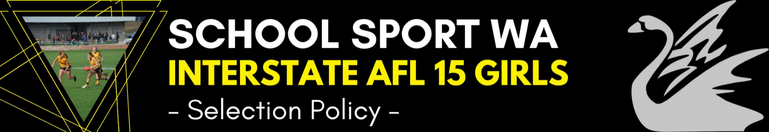

Selectors
- The positions of Coach, Assistant Coaches, Manager and Tour Leader are advertised annually
- The football committee appoints the team selectors at the first meeting held after the appointment of officials
- The Chairman of Selectors is appointed by the football committee
Prior to Selection Trials
- Selectors meet to determine and discuss player selection criteria
- A list of potential state players is compiled from any current and past women’s state players, All Stars, STS Cup players and coach recommendations
Trial Nominations
- Trial dates are determined by the Football Committee
- Details and nomination form are posted on the SSWA Website
- Coach sends an email to all STS team coaches and schools advising them of upcoming trial dates and invites schools and individuals to nominate for trial on the SSWA website.
Pre Trial
- Selectors meet to divide nominees into groups for trial
- Nominees arrive at trial and are allocated a jumper by team manager
- Risk Management documentation is available to all trial participants and schools on the SSWA website
Selection Trials
- All players are advised of selection criteria by coach or Chairman of Selectors prior to commencement of the trial
- Selectors are allocated duties on the day by the Chairman of Selectors
- Successful trialists are notified on the SSWA Website after the trial and invited back to further training sessions
Squad Training
- After a set number of training session, the squad of up to 24 players is announced and a number of players are invited to continue training with the squad as a “Development Squad” member.
Selection Policies
- Players injured before or during the trial process will not necessarily be omitted from the final team and may be invited by the Chairman of Selectors to attend trials or squad training at later dates.
- The Chairman of Selectors may advise country players that they can miss certain trials or training sessions due to travel concerns
- The Chairman of Selectors reserves the right to select a player based on recommendation, who may not have attended the trial.
- Should any Travelling Squad member be ruled out prior to the Championship for any reason then the replacement player would be selected from the Development Squad.
Maali Medal Winner Policy
3 awards will be presented:
- Players Player – voted 2 and 1 by all members of the touring squad
- Coaches Award – subjectively selected by coaching staff looking to reward effort and commitment to the team. This will be based across the lead-up to and over the Championship.
- Most Valuable Player (SSWA Medal Winner) – Coaching staff will vote after each game 3-2-1. The Medal winner will be decided from this.
The swan is the State Emblem of WA also known as the Maali in Nyungar language

