PRIMARY GOLF CONDITIONS OF PLAY

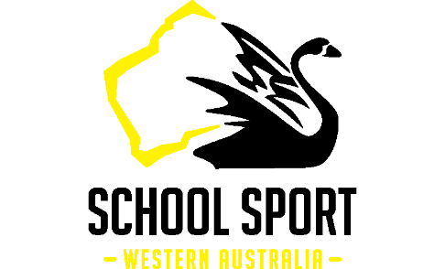
ELIGIBILITY
- Only bona fide primary academic institutions within Western Australia that offer a general education curriculum, with entry qualifications not related to sporting achievement, shall be eligible to compete.
- Only full-time enrolled students in years 2-6 may represent the school.
- It is essential that a teacher or official oversee their team.
- Teams will comprise of two or three competitors (there are no gender restrictions) from the same primary school.
- Individuals may participate and compete for the individual titles, however, are ineligible to compete for the School Teams Championship.
- Players without an official GA handicap may enter (see below) –
- Teams may not be changed once the draw has been made public except in extraordinary circumstances.
- A player may only compete in one SSWA Golf event in each calendar year.
- Players must have a basic standard of golfing ability to participate in this event (see below) - Players with special requirements e.g. have a carer with them on course are welcome but must let SSWA know when entering.
ENTRY FEES
An entry fee of $25 per person (GST inclusive) will be charged and must be forwarded with the entry form.
Stableford Division
- The Stableford Division will be open to eligible players with an official GA handicap only – maximum handicap of 36.0 for boys and 45.0 for girls.
- This field is limited to 60 players. The Team’s Championship will be decided by the best two scores (in a team of 3 the lowest points score will be omitted) by any two competitors from the same school.
- Boys will play off the White tees or such other tees as the committee may decide, and girls will play off the Red tees.
- No caddies will be allowed in this division.
9-hole Modified Stroke Play— off red tees.
- This Non-Handicap Division is open to eligible players without an official handicap only.
- This field is limited to 40 players.
- Modified Stroke rules will be used and outlined by the match committee.
- The two lowest scores by any two competitors from the same school to count towards the team's trophy.
- Both boys and girls will tee off the same tee (red).
- Caddies are allowed in this division.
IN CASE OF TIES In the event of a tie for any position, the Australian Count-back System will be applied using the leading two cards from each team.
TROPHIES FOR THE PRIMARY SCHOOLS GOLF CHAMPIONSHIP
Stableford Play
The team with the highest aggregate score (best 2 scores out of 3 will count) will be the winner of the Primary Schools Teams Championship for 2025.
The best individual scores will be awarded trophies.
Modified Stroke Play
The team with the lowest aggregate score (Modified Stroke Play) (best 2 scores out of 3 will count) will be the winner of the Primary Schools Team Trophy for 2025.
The best individual scores will be awarded trophies.
PLAYER CODE OF CONDUCT
All entrants assent to be bound by the Golf WA Code of Conduct. A copy of the code is available on the Golf WA website www.golfwa.org.au.
CONDITIONS OF PLAY PLAYER STANDARD OF GOLF ABILITY
It is important for entrants to be aware that this competition is not an introduction to golf, rather an introduction to COMPETITIVE golf. As a result, all entrants must have a basic standard of golfing ability i.e. Entrants must own their own clubs and hold a base level skillset which requires being able to drive, putt and chip effectively i.e. be able to keep up with pace of play.
CADDIES
Competitors are asked to note that caddies are not permitted in the Stableford Division. Parents/Supporters must remain as spectators and at least 30 metres away from play except when searching for golf balls and raking bunkers. Caddies are permitted in the Modified Stroke Division but must limit their involvement to pulling bags, raking bunkers and looking for balls.
GENERAL
Entry implies acceptance of the Conditions of Play governing the Championship. These conform with Royal and Ancient rules governing amateur status.
  - No practice rounds are available prior to event.
  - Modified stroke rules as per the Crunch&Sip GolfWA Junior Tour Manual . A copy of the manual is available on the Golf WA website www.golfwa.org.au.
  - The Primary School Teams Championship is conducted by School Sport WA. . The organisers reserve the right to alter the Championship's conditions of play without prior notice.
SUNSMART: All players are to protect themselves against the sun, wear eye protection, hats, caps, sunscreen SPF 30+ and drink ample amounts of water to avoid dehydration.
SMOKEFREE: This is a smoke free event for players, caddies , spectators and team officials.

