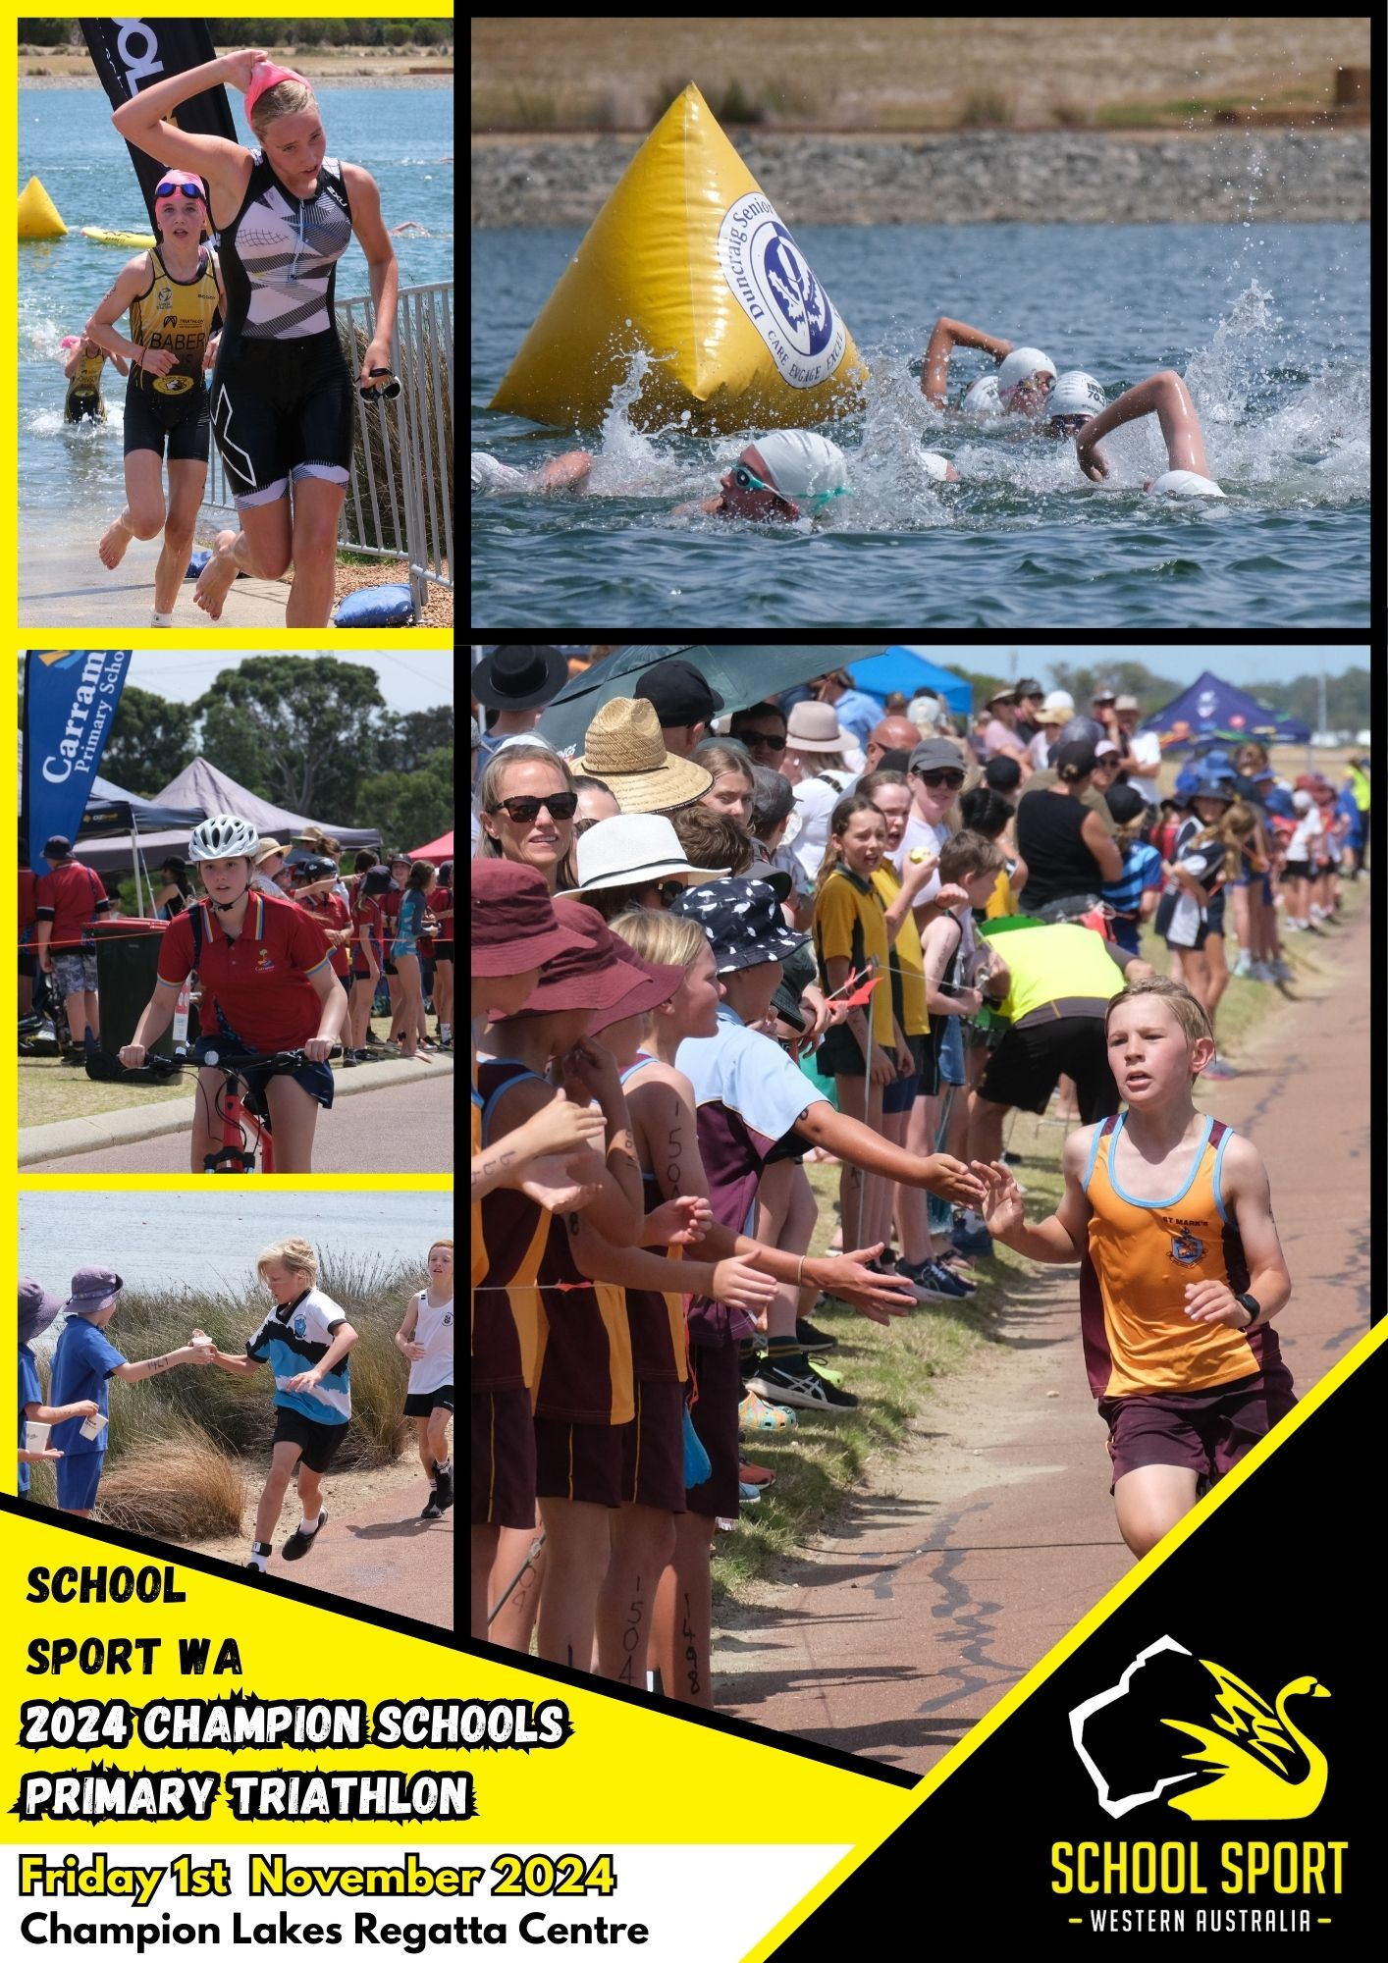
P

TABLE OF CONTENTS

- Acknowledgements ….3

- Introduction 3

- Triathlon Championship Procedures 3

- Program of Events 6

- Course Details 7 - 12

- Parking Guidelines and Plan 13

- State Team Selection 14

1. ACKNOWLEDGEMENTS

School Sport WA would like to thank the following people and organisations for their assistance in the presentation of this event:
Triathlon Western Australia
The Organising Committee
Participating Schools and Competitors
Course Officials and Marshals

2. INTRODUCTION

The 2024 All Schools Triathlon Championship involves 6 different races over a short course, allowing all students to compete in a fun and safe environment. Course descriptions and some maps are included in this booklet.

3. TRIATHLON CHAMPIONSHIP PROCEDURES

This booklet is designed to acquaint schools with administrative and logistical information pertinent to the conduct of a safe and efficient Triathlon Championship. School Administrators are requested to read this information and ensure all participating school commitments are honoured, and that all student competitors are aware of Championship procedures.

- START TIME
Registrations, bike and helmet checking will start at 9am. A race briefing will occur at 9:30am and the program will begin at 10:00am for the first wave. If schools need to travel over a distance, then there needs to be some provision for the early arrival of student participants to allow for events to begin on time.

- PARKING
All parking is on the Western Side of Champion Lakes, there will be access to the car park via a southern gate on Champion Drive.

- REGISTRATION
Competitor numbers will be available on the SSWA website (www.schoolsportwa.com.au) from Monday 28th October. Numbers will also be advertised on the wall of the Regatta centre next to the toilets on the day of the event.
One representative of each school will be asked to come to the registration table upstairs at the Regatta centre to confirm their attendance and receive their timing chips.

- PAYMENT
Following the event, schools will be issued with a tax invoice based on the number of students from their schools.

- SUPERVISION
Facility use and supervision are synonymous. To ensure high standards are maintained we request schools accept responsibility for supervising the behaviour of their own students on the day. It is a requirement that staff monitor toilets and surrounding areas.

Please Note: The swim course will be open 10 minutes before each wave to allow swimmers to warm up. The warm upside of the lake is open for students under the strict supervision of teachers.

All bikes must be left in transition until the end of the event. Students are only allowed to ride their bikes during the race and to and from their school bus. Helmets must be worn at all times.

- FIRST AID
St Johns Ambulance medical personnel will be in attendance at the event to attend to more serious injuries. All schools are requested to provide their own basic First Aid Kit and ice pack for injuries of a less serious nature.

- RACE RULES

Swim:
- No flippers or flotation devices are permitted. Wetsuits, goggles and rash shirts may be used.
- All swimmers must have proven to their school organiser they are capable of swimming at least 300m.

Cycle:
- All competitors in the cycle leg must wear approved helmets (see Cycle Helmet Safety Leaflet in Pre-race instruction package). All helmets will be inspected on race day. Helmets must be fastened before beginning and ending movement of the bike, including the transition area.
- Competitors on a racing bike must compete in A Division. Racing bikes are not permitted to be used in B, C or D Grade
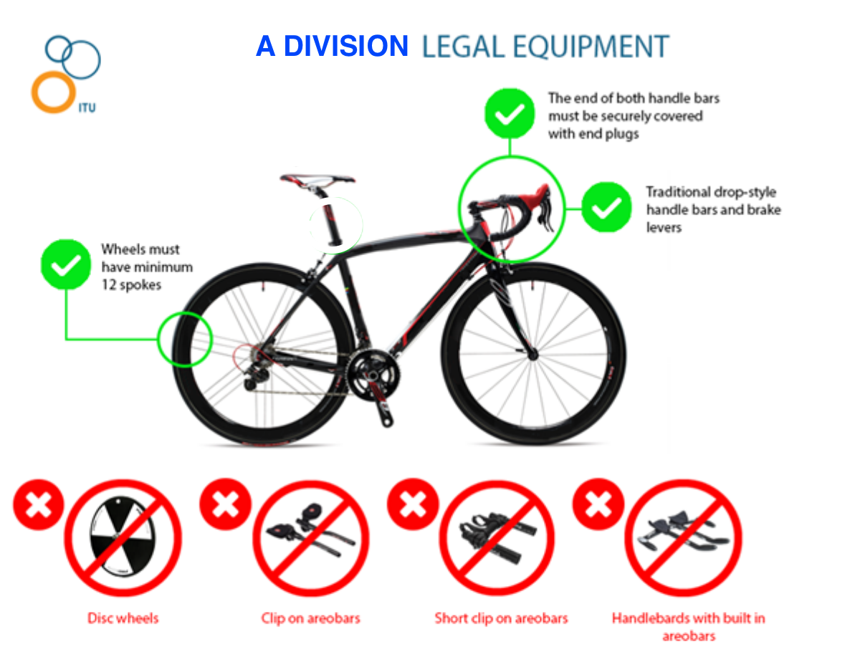
- A distance of at least 2 metres from the edge of the rear wheel of the competitor in front of you to your front wheel must be maintained.
- No support crew is permitted. Competitors are responsible for their own bikes.
- No equipment that protrudes from the bike is permitted (eg pegs, surf racks).
- Brakes must be in working order.
- Shoes must be worn. No bare torsos allowed

Run:
- No other locomotion than running or walking is allowed.
- Shoes must be worn. No bare torsos allowed

Races will start at the scheduled race time. The Regatta Centre will be used as the central coordinating point. Administration/Registration will occur upstairs in the Regatta Centre. Marshals will be stationed around the course, dressed in SSWA orange vests, and will be assisting athletes throughout the event. It is up to the individual athletes to know and follow the course.

- TIMING
Timing bands allow the event to run smoothly and allow athletes to review their race time and individual splits. TIMING BANDS MUST BE WORN ON YOUR LEFT ANKLE. Athletes are responsible for stepping on the timing mat at the end of each leg of their race. Timing mats are located at the entrance and exits of transition area and the finish line. For Relay Teams, the timing band becomes their relay baton, the swimmer must wear the band and then pass it to the cyclist and then cyclist to runner. Timing Bands will be issued based on race numbers and can be collected on the day at Registration.

LOST TIMING BANDS
Timing Bands are an expensive piece of equipment and become the responsibility of the participant once they are collected at registration. All participants must return the timing band to the buckets provided once they have crossed the finish line.
Lost Timing Band Fee of $40 will apply in the event that you do not return your timing band given to you at registration (a window of 10 days following the event is allowed for participants to return your timing band if you forget to do it at the event). No exceptions will be granted or reasons accepted in relation to the issue. Participants who fail to complete the race are required to hand in the timing band at the finish line collection point located in the athlete recovery area.

- RACE NUMBERS ON COMPETITORS
Schools are required to bring along a thick waterproof marking pen to mark the competitors with their number. All competitors are required to be marked. To make it easier for officials we request that numbers be marked on both arms and the front of the right thigh/shin depending upon student race wear.

- GENERAL
Athletes should be prepared for all kinds of weather. Competitors are also advised to bring drinks and food. Refreshments will be available on the day. Occupational Safety and Risk Management Guidelines require that for an event of this nature each student must have their own water supply. School Sport WA highly recommends that all students bring their own water bottle and have it at a place near the finish line.

SCHOOLS SHOULD ALSO NOTE THAT THERE IS LIMITED WEATHER PROTECTION AT THE VENUE SO SCHOOLS ARE ENCOURAGED TO BRING ADEQUATE SHELTER (TENTS) FOR THEIR TEAM, PLEASE ENSURE THESE TENTS/ SHADES ARE SITUATED ON THE GRASS BETWEEN THE ISLAND ROAD AND FOOTPATH ON THE WESTERN SIDE OF THE CHAMPIONSHIP ISLAND.

11. AQUATHLON
The Aquathlon will be broken into age group and gender wave starts. All athletes will have a container within transition area that equipment once finished with must be stored inside. So, when the swim is finished, athletes must place their googles and swim cap in the container. Swim caps will be distributed at the start of each wave. The coloured swim cap must be worn during the swim.

12. TRIATHLON

13. AWARDS
Medallions are given to three team members that are judged to be 1st, 2nd and 3rd respectively in each of the divisions. A plaque award is given to the Champion School based on the following criteria:
- Schools must enter a minimum of 5 teams (regardless of divisions)
- At least one team must compete in A division
- Winning school calculated according to lowest combined time for its fastest five teams

14. RESULTS
A full list of results will be posted on the School Sport WA website on www.schoolsportwa.com.au .

15. QUESTIONS
If you have further questions, please contact Stuart Denton, Stuart.Denton@education.wa.edu.au

4. PROGRAM OF EVENTS

Events will start at the scheduled time. Competitors should assemble 30 minutes prior to the event start for a briefing as all divisions will use the same course.

It is anticipated that rush hour traffic may be a major delay to schools getting to the venue and they MUST keep this in mind when they plan their departure times.

TIME | AGE GROUP | DISTANCE (metres)
9.00 – 9:30am | Inspection of bikes and helmets on entry to transition
9:30am | Race briefing [held in area opposite registration]
10:00am | Aquathlon [run / swim / run] (Male 11 Years) | 1000/200/1000
10:02am | Aquathlon [run / swim / run] (Female 11 Years) | 1000/200/1000
10:04am | Aquathlon [run / swim / run] (Male 10 Years) | 1000/200/1000
10:06am | Aquathlon [run / swim / run] (Female 10 Years) | 1000/200/1000
10:30am | Triathlon [swim / ride / run] (12 years) | 200/4000/2000
11:00am | Race start: C Division | 200/4000/2000
11:20am | Race start: B Division | 200/4000/2000
11:40am | Race start: Female Only Division | 200/4000/2000
12:00pm | Race start: A Division | 200/4000/2000
Approx 1.00pm | Presentations, will be held as soon as possible to the last team that crosses the finishing line

5. COURSE DETAILS

Swim Course

Swimmers will be asked to make a water start. The depth of the water may vary for some competitors and those that may struggle will be given the option of standing in water at a comfortable depth. Swimmers will be given a swim cap that must be worn during the swim as they approach the start area.

All swimmers will complete 1 lap
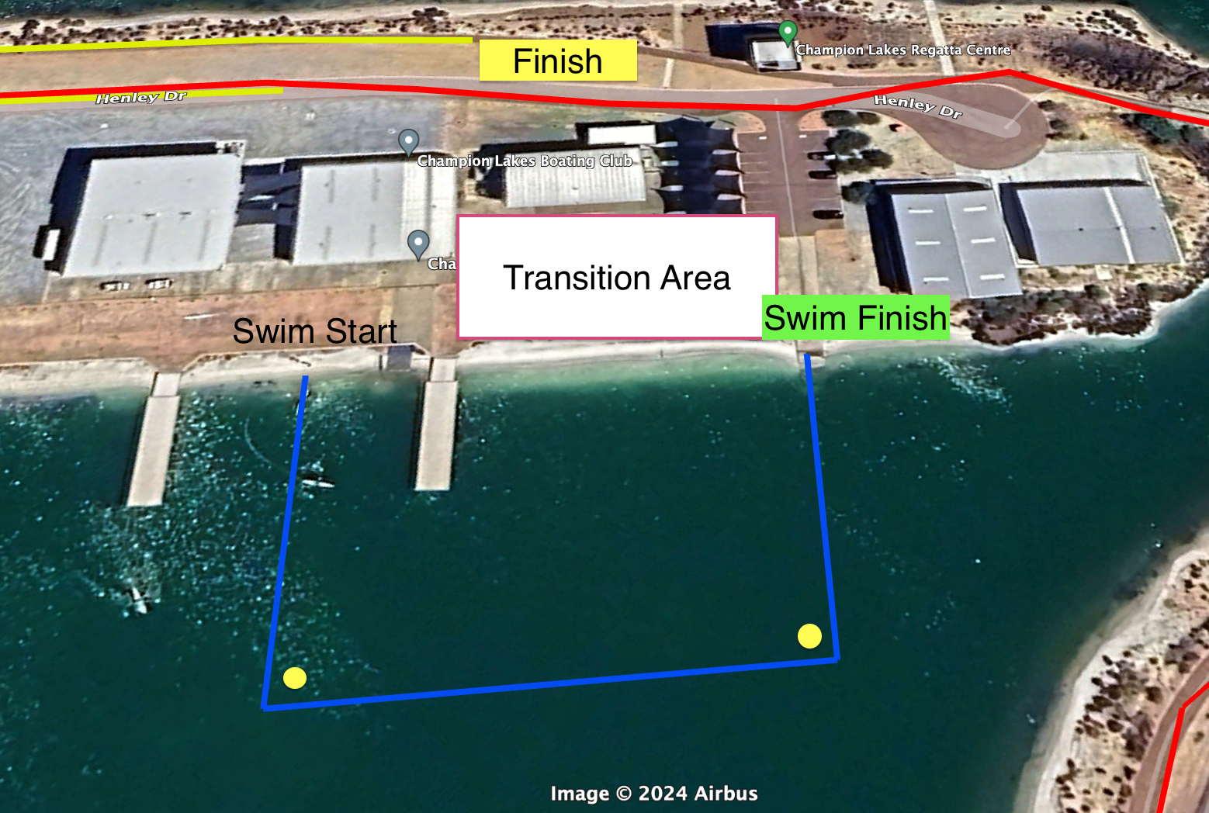

Bike Course

Students are to exit transition area and ride along the Island road, upon crossing the bridge students are to make a sharp left hand turn onto the Events Path. Students are to follow the Events Path around the outside of the Lake. At the pedestrian bridge they are to turn left and ride over the bridge back onto the main island, veering left onto the road they will complete a second lap. At the end of 2 laps they are to dismount their bike and run back into transition area.

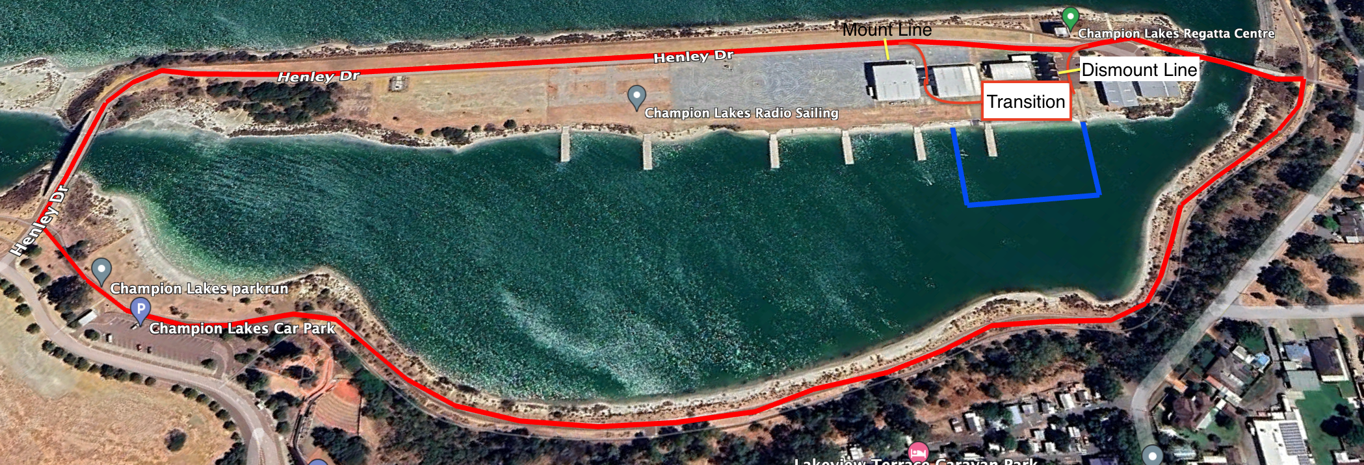

Run Course

Cyclists must have racked their bikes BEFORE they hand the timing chip to the runner.

All runners will complete 2 laps only.

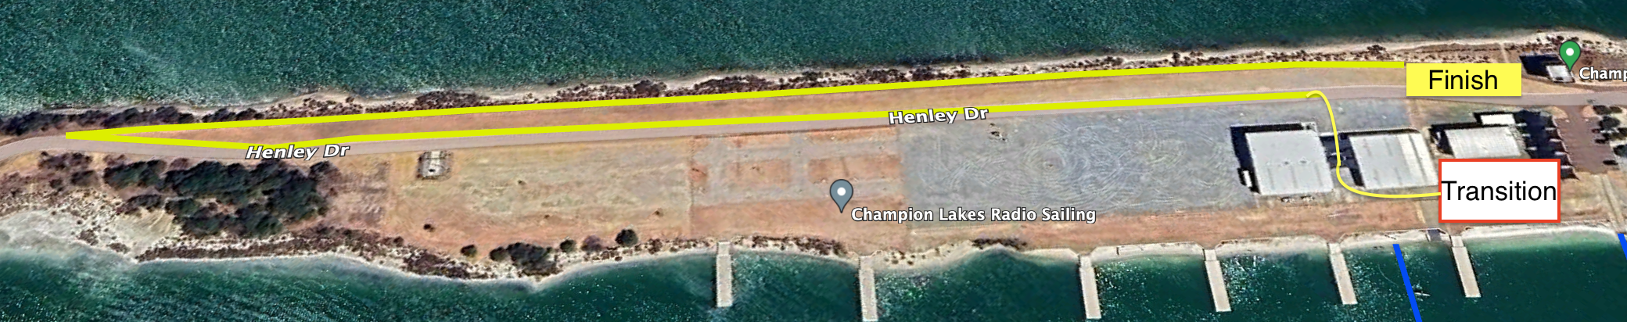

Aquathlon Course

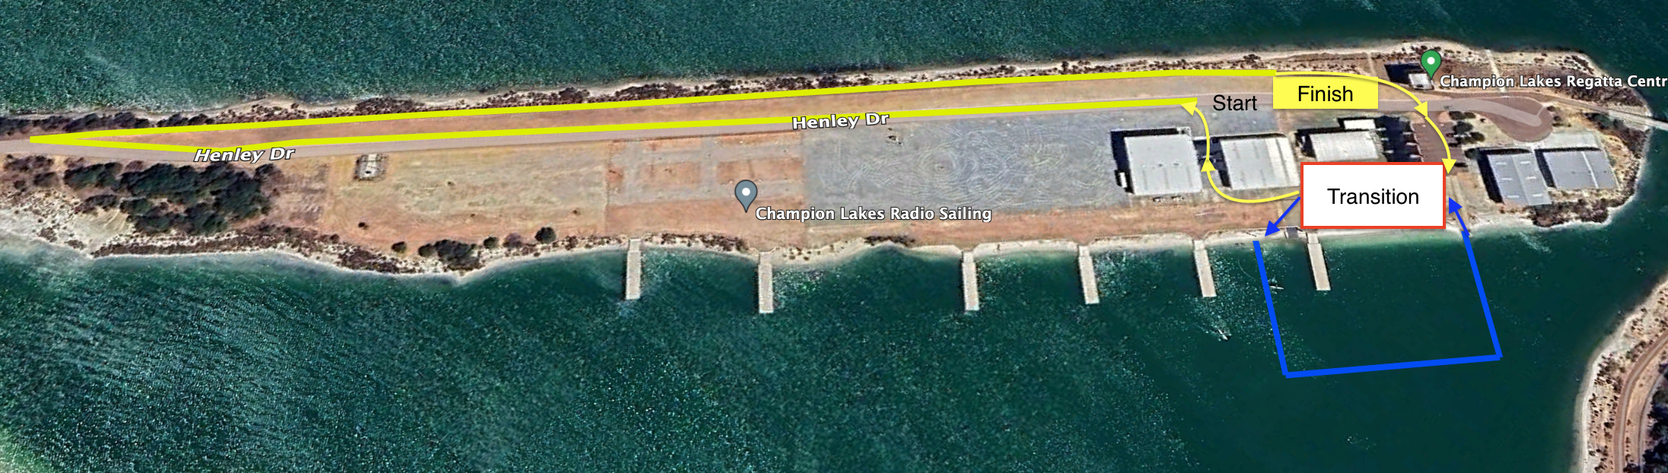
Triathlon Course

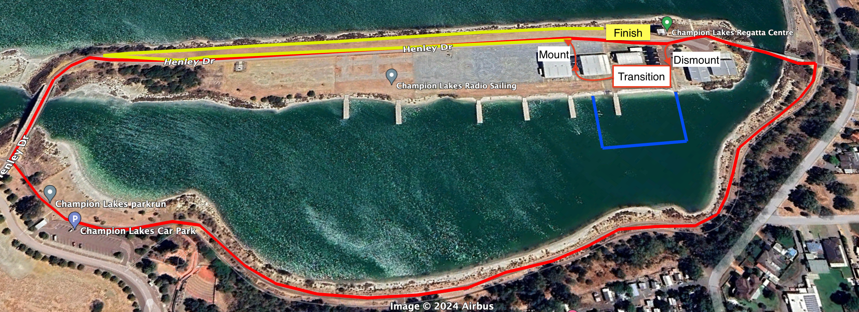

6. TRIATHLON PARKING

Schools are requested to follow the parking plan as shown on the parking map.

Please ensure that the parking plan is provided to all bus drivers/companies and that parents are also advised.

All school buses should be clearly marked with the name of the school to assist staff and students.

Parking: [All Vehicles]

All parking is on the Western Side of Champion Lakes, there will be access to the car park via a southern gate on Champion Drive. No cars or buses will be able to access the internal lake access road until after the last competitor has finished the bike leg, (approx. 1pm). All over flow car parking will need to be on the eastern side of the main bridge to the Island. Any cars parked on the island will only be allowed off the island at certain times under the directions of SSWA Officials.

The grass on the island inside Champion Lakes is not for parking.

Parking Map
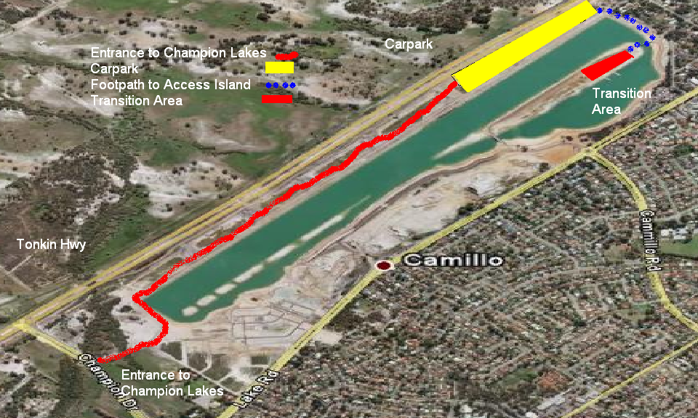

STATE TEAM SELECTION

SCHOOL SPORT WA TRIATHLON - SELECTION POLICY
11 and 12 Year old Aquathlon
SCHOOL SPORT AUSTRALIA NATIONAL SCHOOLS CHAMPIONSHIPS
VENUE AND DATE YET TO BE CONFIRMED

- ELIGIBILITY
- Up to 8 athletes will be considered for selection in each age category.
11 years (born 2014)
12 years (born 2013)

- Age criteria for racing at the School Sport Australia Championships are determined as the age on 31st December 2025.

- Team members are required to be a full time student.

- Selected athletes will be required to travel and accommodate with a parent or nominated guardian.

- SELECTION CRITERIA

- Participation in the School Sport WA Aquathlon event at the Primary School Triathlon Championship is required for selection consideration.

Team selection will be determined as follows:
Athletes placing in the top 8 for their particular age group will receive automatic selection. In the event that an athlete does not take up the offer to participate at the School Sport Australia event an offer will be made to the next highest placed athlete.

- APPLICATONS
Immediately after the Aquathlon event all athletes who place in the top 15, for their age group, will receive information about the School Sport Australia Aquathlon event. Athletes who wish to be considered for a position in the team must go to the School Sport WA website and complete a Primary Interstate Triathlon Nomination.

This nomination form will be available on the SSWA website from 9am on Monday 4th November and must be submitted online by Monday 25th November 2024.

- FURTHER INFORMATION
Further information is available on the School Sport WA website: www.schoolsportwa.com.au Please provide this information to your students entering the selection race.

The SSWA State Team will be announced on Monday 9th December 2024.

