CROSS COUNTRY COURSE MAPS

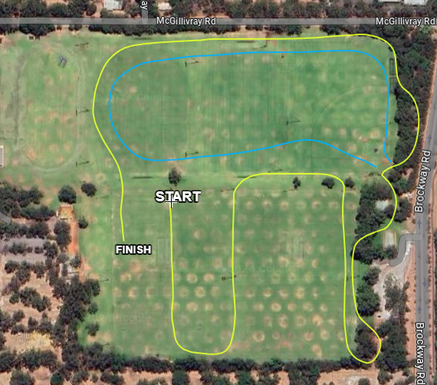

2km and 4km
Follow the YELLOW loop ONLY
2km ONE LAP
4km TWO LAPS

3km and 6km
Follow the YELLOW AND BLUE loops
3km ONE LAP
6km TWO LAPS

