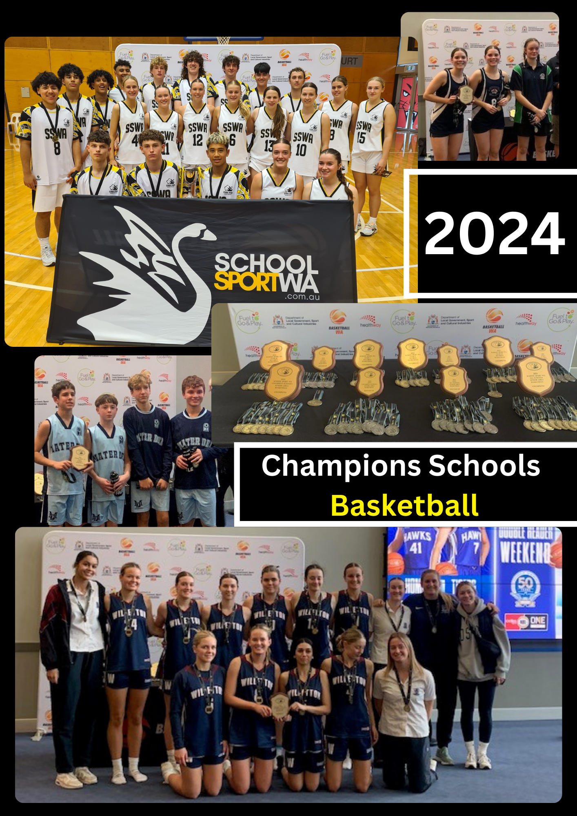

SECONDARY CHAMPION SCHOOL BASKETBALL OVERVIEW - 2024

In 2024 the Senior and Junior Leagues have undergone a restructure, with some Leagues combined. Most Leagues will be run as day-carnivals, however, there will be North of the River and a South of the River Specialist Schools Leagues run as an after-school home and away competition throughout Terms 1 and 2.

Senior Competition

- North of the River and South of the River Specialist Programs Leagues (Champion Schools) played on a home and away basis after school throughout Terms 1 and 2

- Regional Leagues (All-Schools) played as day-carnivals during Term 2

The Champion Schools Grand Final will be contested by the two top teams after the NOR and SOR home and away competition, followed by cross-over semi finals.

The top team from each of the Regional League day-carnivals will be invited to attend the All-Schools Day Carnival ( previously run as an after school elimination competition). The two top teams at the completion of the All Schools Day Carnival will progress to the Senior All-Schools Grand Final.

All Grand Finals will be held at Bendat Stadium on a date to be advised during Term 2 in 2024.

There is a possibility that Specialist Schools may enter their second or third teams in the General day carnivals, however, these teams will be ineligible to progress to the All Schools finals.

Junior Competition

Junior Leagues will conduct their competitions as one-day carnivals. All Specialist Schools will compete in their own day carnivals separate to the All-Schools day carnivals. The two top teams from each of the Specialist Day Carnivals will contest the Junior Champion Schools Grand Final.

Following the completion of the Regional Junior Leagues day-carnivals, the top team from each League will be invited to attend the All-Schools Day Carnival. The two top teams at the completion of the All Schools Day Carnival will progress to the All-Schools Grand Final.

There is a possibility that Specialist Schools may enter their second or third teams in the General day carnivals, however, these teams will be ineligible to progress to the All Schools finals.

2024 Organising Committee

Robyn Brierley Executive Officer, School Sport WA
Kelvin Browner Basketball Coordinator, School Sport WA

The Organising Committee would like to thank all School administration and teaching staff for their support of the competition and encouraging their Schools to participate in the competition.

The 2024 Coordinators are:

North of the River Specialist | Kelvin Browner
South of the River Specialist | Blair Kearsley
Airport / Southern Suburbs League | Sean Fagan
Beach Alkimos League | Kelvin Browner
Canning River League | Blair Kearsley
Central Railway League | Kurt Slabolepszy
Harbour League | Stephen Watson
Hills League | Steve Bezant
Northern Suburbs League | Joshua Daniells
Peel League | Stephen Watson

2023 Secondary Champion School Results

Congratulations to the below teams on their success in 2023.

Division | Winner
Senior CS Boys | Willetton SHS
Senior CS Girls | Willetton SHS
Senior All Schools Boys | Churchlands SHS
Senior All Schools Girls | Mandurah CC
Junior CS Boys | Willetton SHS
Junior CS Girls | St Norbert College
Junior Shield Boys | Rossmoyne SHS
Junior Shield Girls | Carine SHS
3x3 Boys 10’s | Willetton SHS
3x3 Boys 7’s | Mater Dei
3x3 Girls 10’s | Mt Lawley SHS
3x3 Girls 7’s | Willetton SHS

Champion Schools History
YEAR | SENIOR CHAMPION SCHOOLS WINNERS |  | JUNIOR CHAMPION SCHOOLS WINNERS
 | BOYS | GIRLS | BOYS | GIRLS
2023 | Willetton SHS | Willetton SHS | Willetton SHS | St Norbert College
2022 | Willetton SHS | Willetton SHS | Willetton SHS | Willetton SHS
2021 | Woodvale SC | Kennedy Baptist College | Willetton SHS | Willetton SHS
2020 | Cancelled Due to COVID -19 |  | Willetton SHS | Woodvale SC
2019 | Willetton SHS | Kennedy Baptist College | Willetton SHS | Willetton SHS
2018 | Willetton SHS | Kennedy Baptist College | Willetton SHS | Willetton SHS
2017 | Willetton SHS | Kennedy Baptist College | Willetton SHS | Willetton SHS
2016 | Woodvale SC | Willetton SHS | Willetton SHS | Willetton SHS
2015 | Aquinas College | Woodvale College | Willetton SHS | Mandurah CC
2014 | Willetton SHS | Willetton SHS | Kennedy Baptist College | Woodvale SC
2013 | Willetton SHS | Willetton SHS | Willetton SHS | Willetton SHS
2012 | Woodvale SC | Willetton SHS | Willetton SHS | Willetton SHS
2011 | Willetton SHS | Willetton SHS | Willetton SHS | Willetton SHS
2010 | Willetton SHS | Willetton SHS | Kolbe CC | Willetton SHS
2009 | Willetton SHS | Willetton SHS | Woodvale SHS | Willetton SHS
2008 | Willetton SHS | Willetton SHS | Woodvale SHS | Willetton SHS
2007 | Willetton SHS | Willetton SHS | Woodvale SHS | Willetton SHS
2006 | Aquinas College | Willetton SHS | Willetton SHS | Woodvale SHS
2005 | Willetton SHS | Willetton SHS | No Competition
2004 | Willetton SHS | Woodvale SHS
2003 | Aquinas College | Woodvale SHS
2002 | Willetton SHS | Willetton SHS
2001 | Woodvale SHS | Willetton SHS
2000 | Willetton SHS | Willetton SHS
1999 | Willetton SHS | Willetton SHS
1998 | Willetton SHS | Willetton SHS
1997 | Willetton SHS | Willetton SHS
1996 | Willetton SHS | Willetton SHS
1995 | Willetton SHS | Willetton SHS
1994 | Willetton SHS | Willetton SHS
1993 | Willetton SHS | Willetton SHS
1992 | Willetton SHS | Willetton SHS
1991 | St Mark’s College | Willetton SHS
1990 | CBC Fremantle | Mercedes College
1989 | Rossmoyne SHS | Mandurah SHS
1988 | Willetton SHS | Warwick SHS
1987 | Willetton SHS | Churchlands SHS

All-Schools History

YEAR | SENIOR ALL-SCHOOLS WINNERS |  | JUNIOR ALL-SCHOOLS WINNERS
 | BOYS | GIRLS | BOYS | GIRLS
2023 | Churchlands SHS | Mandurah CC | Rossmoyne SHS | Mater Dei College
2022 | Mandurah CC | Shenton College | Shenton College | Carine SHS
2021 | Shenton College | Shenton College | Shenton College | Mandurah CC
2020 | Cancelled Due to COVID -19 |  | Rockingham SHS | Mandurah CC
2019 | Mandurah Catholic College | Shenton College | Woodvale SC | Kennedy Baptist College
2018 | Churchlands SHS | Mandurah Catholic College | No competition
2017 | Churchlands SHS | Mandurah Catholic College
2016 | Mazenod College | Kennedy Baptist College
2015 | Shenton College | Seton Catholic College
2014 | Kennedy Baptist College | Corpus Christi
2013 | Ellenbrook College | Emmanuel College
2012 | Kingsway CC | Clontarf
2011 | Kingsway CC | Emmanuel College
2010 | Winthrop BC | La Salle College
2009 | Kingsway College | La Salle College
2008 | CBC Fremantle | Mandurah CC
2007 | CBC Fremantle | Mandurah CC
2006 | Trinity College | St Stephen’s School

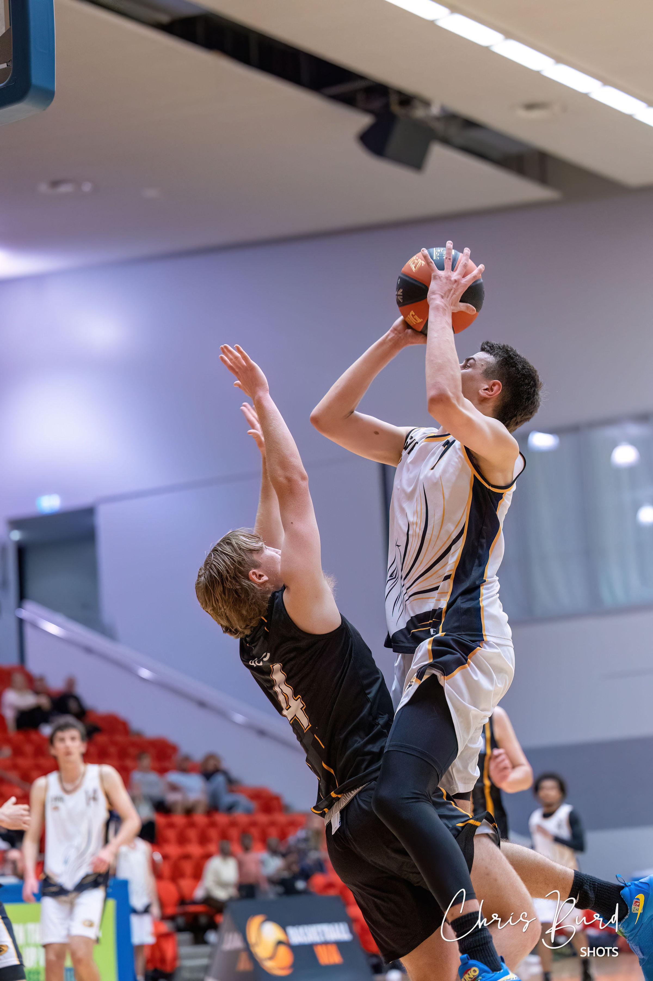

CHAMPION SCHOOLS BASKETBALL 2024

AIMS AND OBJECTIVES OF THE COMPETITION
1. To improve the standard of basketball in schools.
2. To improve the image of schools as a focal point of a student's sporting life.
3. To encourage sports persons to continue their education.
4. To identify and strengthen a strong sense of loyalty to the school and a strong school spirit for the competitors, students, staff, parents and the Community.
5. To make High Schools self-sufficient in the techniques and skills of administering a high standard basketball competition.

ELIGIBILITY
1. All High Schools in the State of Western Australia, including Government and Non-Government High Schools in both the metropolitan and country areas.
2. Each school may nominate one boys and one girls team in each division. If places in the League allow, schools may nominate a second team with the approval of the Organising Committee. The divisions are:
- Senior Champion School (years 7 -12, 18 years or under in the year of competition).
- Junior Champions Schools (years 7- 9, and under 15 years in the year of competition)
- Year 7 3X3
- Year 10 3X3
3. Players must be enrolled full-time at the school.
4. Players come from any year group for the Senior Competitions, and must be years 7 - 9 for the Junior Competition

COMPETITION STRUCTURE
- Leagues
All schools wishing to compete will be placed in a "League" which will be arranged by geographic areas.

- League Co-ordinators
Each League will have a "League Co-ordinator" who will be responsible for setting up a round-robin or all-day competition. The purpose of the round robin or day-carnival is to select the best teams in each league to progress to the finals series.

- Dates
The Senior Champion Schools competitions will be conducted in Terms 1 and 2, and the Junior Champion Schools will be conducted in Term 3 of the school year.

Senior Competitions
Nominations completed online with School Sport WA
Fixtures e-mailed to schools by League Co-ordinators following close of nominations.

Each League will start at the decision of the Coordinator depending on number of teams, as long as games are completed by Friday 17May 2024.

Friday 17 May 2024 – Last day for Regional games.
Tuesday 28 May 2024 – All Schools League Winners day carnival
Tuesday 25 June 2024 - Boys / Girls Grand Finals – (Girls 3.00pm Tip off; Boys 4.30pm Tip off).

Junior Competitions
Dates for all Junior Carnivals will be set in Term 2 to allow schools time to organise. These will be published on https://www.schoolsportwa.com.au/interschool/secondary/basketball/

All Junior carnivals will take place during week 3 to 5 of term 3 (5 August – 25 August 2024)
Tuesday 29 August – All Schools League Winners Day Carnival (TBA)
Tuesday 19 September– Boys / Girls Grand Final (Girls 3.00pm Tip off; Boys 4.30pm Tip off).

- Finals
Finals fixtures will be arranged by the School Sport WA Basketball Coordinator. Senior finals will be held out of school hours.

Senior Finals will be in two divisions:

Senior Champion Schools Basketball – Winners from the cross-over finals between the NOR and SOR Specialist Leagues, with the winning school in both boys and girls being invited to attend the National Schools Championships Division conducted by Basketball Australia.

Senior All Schools Basketball – Teams will play in their own Leagues, followed by a day carnival for the winners of each League. The top two teams from this day carnival will contest the All-Schools Grand Final.

Non-specialist Government Schools only. As of 2019 ACC Schools were not accepted into this competition.

Schools are only permitted to play in ONE division in the Senior Finals.

Junior League – Grand finals will be held at the Bendat Basketball Centre, after the completion of North and South of the River Specialist Schools finals and the All-Schools Leagues. The winning teams from each League carnival will play off in the All Schools League Winners day carnival, with the top two teams contesting the Grand Final.

- Venues
The venues for the round robin finals and the knock-out finals will be arranged by the home school. The venues for the Grand Finals will be neutral and will be booked and paid for by School Sport WA.

- Fixtures
The fixtures (days and times of competition) for the leagues will be set up by the League Co-ordinators in co-operation with all school representatives of their League.

- Game Timing
The timing of all finals games will be 4 x 8 minute quarters; fully timed (the clock will stop on all whistles).

- Referees
The finals games will be refereed by qualified Basketball WA referees. Sport Staff One (https://ssoaustralia.com/ ) and Reffing Hoops (enquiries@reffinghoops.com.au ) have indicated they may be able to assist schools in 2023.

For ALL qualifying games, schools in each League must supply ONE competent referee.
Referees used by schools must have refereed previously (Students or external referees) or have significant knowledge of the rules of basketball (teachers).

- Team Make-up
The teams in this competition may consist of between five and twelve players.

- Numbers
The following numbers may be worn on player uniforms:
00 – 99.

SPECIALIST SCHOOLS BASKETBALL COMPETITION

Rules and Regulations of Play

Below are the rules, regulations and fixtures for the new Specialist Schools’ Basketball competition for 2024.

The competition will have each team playing eight games. You will play all the other schools in your League twice in a home and away fixture. Placings on the ladder will be decided by wins and losses – in the case of a tie, final placings will be decided by head-to-head between the teams involved. Percentage is the last factor.

Games need to follow the rules and regulations below:

- Home team is mentioned first in the fixtures.
- Each teams must provide an umpire and score bench officials for each game – if schools cannot
provide these, they need to negotiate with the opposing school or seek to pay for an umpire to come in.
- Schools can play up to 12 players in each game.
- Games will consist of 4 x 10 minute (stop clock) quarters. In the case of time being a factor at the
venue, schools can negotiate (prior to the day) to play 4 x 8 minute (stop clock) quarters but this should
only be as a last resort.
- Shot clocks need to be provided for the games – if they can’t be provided, home venue schools need
to alert the opposing school prior to the day of the game and try and come up with an arrangement.
- Normal Team Foul Penalty for each quarter – shooting free throws on the 5th team foul.
- 2-time outs allowed in the first half and 3 in the second half – normal rules.
- 5-minute overtime is to be played in the case of a draw at the end of regulation.

- All results are to be emailed by the home team to the League Coordinator within 24 hours of the game.
Please scan or take a photo of the score sheet and send it in with the result.
- Games may be rescheduled due to exams, excursions, camps or player availability however you
must inform the coordinator if the game is not going to happen in the week of the fixture and it must be played within the competition timeline.

ACC vs SSWA ALL-STARS GAME

The inaugural ACC vs SSWA Boys and Girls All Stars games were held in 2014. Following its great success this has become an annual event. The date for the 2024 All-Stars game is Sunday 22 October 2023.

Details are available on the SSWA Website. The games will be held at Bendat Basketball Centre.

Expressions of Interest – Head Coach, Assistant Coach and Team Manager will open at the beginning of term 2, 2024. EOI’s will be accepted from current Department of Education staff ONLY.

Students wishing to be considered for the SSWA All Stars team will be required to complete an online nomination. Subject to numbers trials may be held in week 7 or 8 of term 3.

Results

Year | Boys | Girls
2023 | SSWA | ACC
2022 | ACC | SSWA
2021 | ACC | ACC
2020 | Event not held due to COVID -19
2019 | ACC | ACC
2018 | ACC | ACC
2017 | SSWA | ACC
2016 | SSWA | SSWA
2015 | ACC | SSWA
2014 | SSWA | SSWA

School Sport WA Secondary
Champion Schools Basketball - Metropolitan Leagues 2023

SOUTH OF THE RIVER LEAGUES

SPECIALIST SCHOOLS LEAGUE

Coordinator: | Blair Kearsley
School: | Willetton Senior High School
Phone: | 9334 7200
Email: | Blair.kearsley@education.wa.edu.au
Darling Range Sports School
Kennedy Baptist College
Rockingham SHS
St Norbert College
Willetton SHS

AIRPORT / SOUTHERN

Coordinator: | Sean Fagan
School: | Rossmoyne Senior High School
Phone: | 9259 2127
Email: | Sean.fagan@education.wa.edu.au
Armadale Senior High School
Belmont City College
Canning Vale College
Cecil Andrews Senior High School
Clontarf Aboriginal College
Como Secondary College
Harrisdale Senior High School
Kelmscott Senior High School
Lumen Christi College
Lynwood Senior High School
Rehoboth Christian College
Sevenoaks Senior College
Thornlie Senior High School
Yule Brook College

CANNING RIVER

Coordinator: | Blair Kearsley
School: | Willetton Senior High School
Phone: | 9334 7200
Email: | Blair.kearsley@education.wa.edu.au
All Saints’ College
Applecross Senior High School
Atwell College
Corpus Christi College
Lakelands Senior High School
Leeming Senior High School
Melville Senior High School
Murdoch College

HARBOUR

Coordinator: | Stephen Watson
School: | Rockingham Senior High School
Phone: | 9553 0100
Email: | Stephen.watson@education.wa.edu.au
Baldivis Secondary College
Byford Secondary College
CBC Fremantle
Divine Mercy College
Emmanuel Catholic College
Gilmore College
Living Waters Lutheran College
Peter Carnley Anglican Community
Safety Bay Senior High School
Seton Catholic College
South Coast Baptist College
Tranby College
Warnbro Community High School

HILLS

Coordinator: | Steve Bezant
School: | Swanview SHS
Phone: | 9294 1844
Email: | stephen.bezant@education.wa.edu.au
Carmel Adventist College
Eastern Hills Senior High School
Governor Stirling Senior High School
Guildford Grammar School (Girls)
Helena College
Kalamunda Senior High School
La Salle College
Lesmurdie Senior High School
Mazenod College
Mundaring Christian College
Swan Christian College
Swan View Senior High School

PEEL

Coordinator: | Stephen Watson
School: | Rockingham Senior High School
Phone: | 9553 0100
Email: | Stephen.watson@education.wa.edu.au
Comet Bay College
Coodanup College
Frederick Irwin Anglican School
Halls Head College
John Tonkin College
Kolbe Catholic College
Mandurah Baptist College
Mandurah Catholic College
Mother Teresa Catholic College

NORTH OF THE RIVER LEAGUES

SPECIALIST SCHOOLS LEAGUE

Coordinator: | Kelvin Browner
School: | School Sport WA
Phone: | 0403 034 050
Email: | Kelvin.browner@education.wa.edu.au
John Septimus Roe
Kiara College
Kingsway College
SEDA College
Woodvale Secondary College

BEACH AND ALKIMOS

Coordinator: | Kelvin Browner
School: | School Sport WA
Phone: | 0403 034 050
Email: | Kelvin.browner@education.wa.edu.au
Alkimos High School
Alkimos Baptist College
Belridge Secondary College
Bullsbrook College
Butler College
Clarkson Community High School
Joseph Banks Secondary College
Kinross College
Mater Dei College
Mindarie Senior College
Northshore Christian Grammar
Ocean Reef Senior High School
St Stephen’s School, Carramar
Wanneroo Secondary College
Yanchep High School

CENTRAL RAILWAY

Coordinator: | Kurt Slabolepszy
School: | Kiara College
Phone: | 9378 0200
Email: | Kurt.slabolepszy@education.wa.edu.au
Aveley College
Bob Hawke College
Carmel School
Churchlands Senior High School
Cyril Jackson Senior Campus
Ellenbrook Secondary College
Hampton Senior High School
John Forrest Secondary College
Mount Lawley Senior High School
Perth Modern School
Shenton College

NORTHERN SUBURBS

Coordinator: | Joshua Daniells
School: | Aveley Secondary College
Phone: | 6296 1000
Email: | Joshua.daniells@education.wa.edu.au
Ashdale Secondary College
Balcatta Senior High School
Balga Senior High School
Ballajura Community College
Carine Senior High School
Dianella Secondary College
Duncraig Senior High School
Girrawheen Senior High School
Landsdale Christian School
Mercy College
Warwick Senior High School

