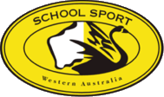

SCHOOL SPORT WA

SPORT COORDINATOR NOMINATION FORM

Please complete the below information and email to school.sport@education.wa.edu.au

NOMINATIONS CLOSE AT 12PM on Thursday 7 March 2024

APPLICANT’S NAME
POSITION
DATE
SIGNATURE (Applicant)
NOMINATED BY
(Print Name)
SIGNATURE
SECONDED BY
(Print Name)
SIGNATURE

