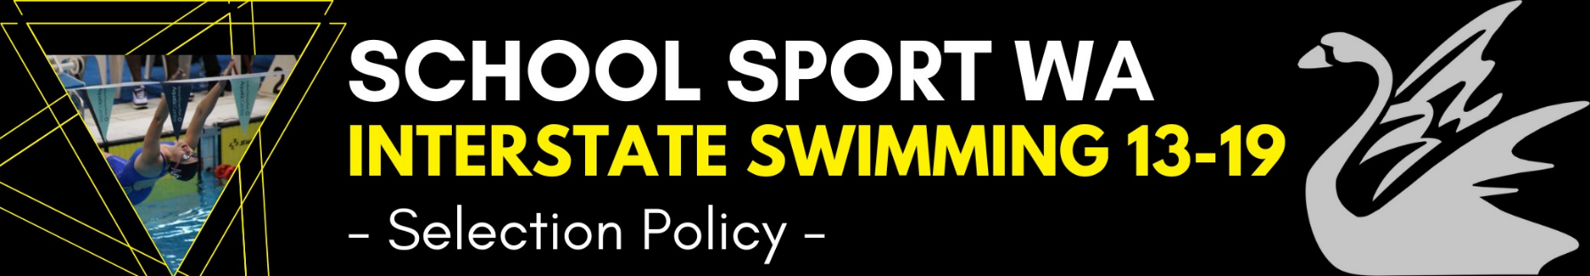
Last Updated:
2022
Selectors
The School Sport WA (SSWA) swimming committee will appoint selectors to undertake the process of selecting the State team.
Selection Process
- Team selection criteria listed will be adhered to in all cases, except where exceptional circumstances may prevail.
- Championship events will be listed on the SSWA website, once they are made available.
- Ages are taken as at 31 December in the year of competition.
- Ages 13-19
- Prospective competitors MUST nominate via online form on the SSWA website.
- Prospective team members must complete the official online nomination in full and submit on, or prior to, the prescribed date.
- Late nominations will not be accepted.
- Team selection will be based on Long Course times only taken from 31 October in the year prior to SSA Championship.
- Trials are not conducted to select the SSWA Swim team. The squad will be selected with times from Swimming WA endorsed events only.
- SSWA reserves the right to limit the overall team size.
- All swimmers will be considered for individual events, consideration will also be given to the resulting full team size.
- Team members will be required to adhere to all SSWA Policies and Processes.
- Team membership offers will be made two (2) weeks after close of nominations. Swimmers will then be advised of the procedures to be followed to formally accept such an offer.
- A Squad announcement will be announced 2 weeks after close of nominations. Each swimmer is guaranteed 2 individual swims and 1 relay swim. Final event list will be realised 2 weeks prior to deposits due.
- Should a team member withdraw prior to the Championship, the selections committee may select a replacement swimmer from the existing team or from other nominees.
- Rules for Multi-class – Must meet a qualifying time of 150% of the World Record for their classification and event. Other times may be considered, but not necessarily accepted

