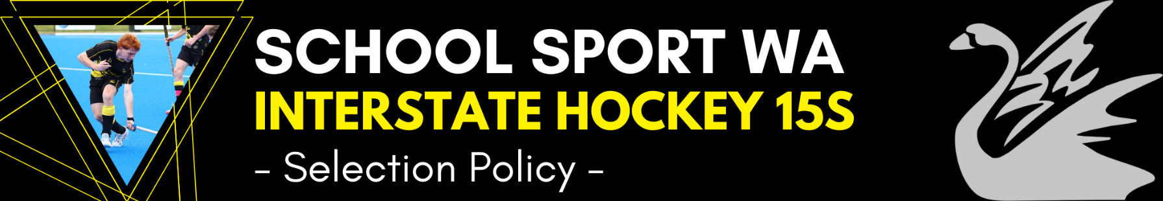
Last Updated:
2022
The Hockey Interstate teams shall consist of 16 players, including a minimum of one goalkeeper. The other fifteen players will consist of a balanced selection of field position players with the potential to include a second goalkeeper.
In order to select the players for the team, the following will apply.
- Players must complete the official nomination form and pay the required Trial Fee. ($50 for all age groups –to cover ground hire, balls, bibs etc).
- A copy of the Nomination Form and details about the Trial Fee will be available on the School Sport WA website. (www.schoolsportwa.com.au). Payment must be received prior to the nomination being accepted.
- The Team Managers shall administer the selection process.
- The Team Coach shall be the chief selector.
- The Appointed Team Officials shall appoint other Selectors as required. A minimum of three selectors shall be used for all trials.
- No selector shall be involved in the selection of any player who is directly related to them.
- A maximum of four trials to be held. Each trial can consist of a number of shortened games of between 20 and 30 minutes duration where possible. The number of players carried through from each trial to the next is at the discretion of the selectors.
The Bevan George Shield (One Day Round Robin Tournament) will act as the Initial trial for the Secondary Boys.
- All trials will be held on synthetic turf surfaces. [School Sport Australia policy]
- Whilst trialling, players are to wear the allocated singlet with a unique number to avoid confusion.
- Attendance at all trials is compulsory unless exceptional circumstances (School Assessments & Camps) apply and prior permission is sought wherever possible from the Coach or Manager.
- Goalkeepers may be given a series of practical skill tests in addition to game play. Wherever possible a specialist Goalkeeper Selector shall be appointed.
- Trials may incorporate skill drills for players as well as match play.
- Every endeavour shall be given to trialling players in the positions they have submitted on the Nomination Form. At this elite level, players must be able to play in a variety of positions. Selectors reserve the right to trial players in equivalent positions e.g. Striker, Midfield or Defence.
- Selectors shall consider all aspects of the game including (but not limited to) physical ability, skill, tactics, attitude and behaviour.
- Selectors shall reach decisions by consensus wherever possible. If consensus cannot be reached, a vote by the three main selectors shall be held.
- When selecting one player before another, selectors shall make an “on balance” decision, based on all the attributes and abilities shown by the players. Such “on balance” decisions are consistent with selection processes used for other elite teams in the hockey community.
- When selecting the final team of sixteen, selectors shall consider the balance of the squad in terms of positional play. The team shall include one goalkeeper as a minimum.
- Selectors should choose the team of sixteen players at the end of the final trial. In exceptional circumstances, selectors may delay the naming of the team to evaluate players during training sessions. In such circumstances, a squad of no more than 24 should be named for the training sessions.
- Selectors may name extra players to train on with the squad to cover possible injuries or withdrawals.
- Due to time constraints with the trial process selectors shall consider performance at the trials initially and refer only to a players past history in the event that the selectors feel that the player did not perform in the best of their ability or potential during the trial process. This consideration would also include any outstanding injury or external circumstances that may have been affected the player’s performance during the trials.
- Injured players may be given time to trial by being exempted from early trials or by being included in train on squads provided the timeline is sufficient to enable adequate preparation after selection. Players being treated for injury or illness are required to provide a statement of their condition, time frame for return to full fitness and limitations from their treating practitioner. The selectors reserve the right to select a player who is injured during the trial process.
- Once a team or squad is selected, attendance at training is compulsory; unless exemption is granted prior by the coach. Initial decisions to be made by consultation between player and coach. If consensus cannot be reached, parents and manager shall be consulted. If consensus cannot be reached, the SSWA Sport Convenor shall be consulted.
MEDAL WINNER POLICY
The Medal winner will be decided by all team officials voting on a 10 scale rating system after each game. The player with the most votes at the end of the Championship will be named the Medal Winner.

