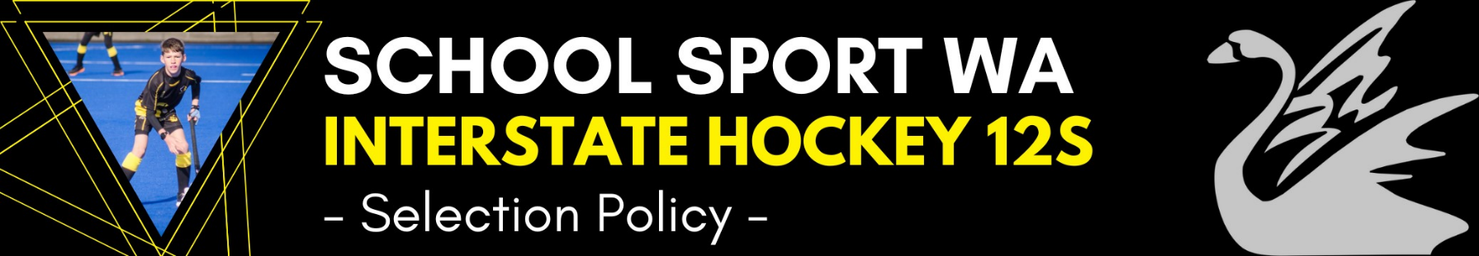
Last Updated:
Dec 2023
The teams shall consist of 14 players. One will be a goalkeeper and the other thirteen players will be a balanced selection of field position players. Any variation from this will require approval from SSWA.
Girls & Boys 12 Years & Under (i.e. 11* or 12 years of age as of 31st December in year of championship). The child cannot be turning 13 in the year of championship.
* Students who turn 11 in the year of competition and are selected in the final team must be accompanied by a parent or nominated guardian.
Criteria
- Basic Skills – players who can consistently demonstrate highly developed basic skills in:
- Dribbling
- Passing & Receiving
- Tackling
- Communicating
- Understanding of position play – players who clearly understand the attacking and defensive requirements of the positions they play. Able to play in multiple positions (GK exempted).
THEN (in no priority order)
- Team Skills – players who unselfishly support the team, encourage others, communicate well, and get on with their peers.
- Attitudes – players who are tenacious, determined, resilient and creative.
- Potential – players who show potential for the future.
- Speed & Endurance – offensive and defensive.
- Strength – acceleration, hitting speed, agility, ability to ride interference.
Other Selection Criteria
To select the players for the team, the following will apply:
Attendance at ALL trials is compulsory unless exceptional circumstances apply, and prior permission is sought wherever possible from the coach or manager.
- Players must complete the official nomination form and pay the required Trial Fee. ($50 to cover ground hire, balls, bibs etc). A copy of the Nomination Form and details about the Trial Fee will be available on the School Sport WA website. (www.schoolsportwa.com.au).
- The selection process and selectors are decided upon by the team officials.
- A minimum of three selectors shall be used for all trials. Ideally the same selectors shall be used for all trials. Where more than three selectors are used, three selectors shall be nominated as the main selectors.
- No selector shall be involved in the selection of any player who is directly related to them.
- A maximum of four trials to be held. The number of players carried through from each trial to the next is at the discretion of the selectors.
- Notification of players proceeding to the following trial will be via the SSWA website (www.schoolsportwa.com.au)
- All trials will be held on synthetic turf surfaces. [School Sport Australia policy]
- Whilst trialling, players are to wear the allocated singlet with a unique number to avoid confusion.
- Goalkeepers shall be given a series of practical skill tests in addition to game play. Wherever possible a specialist Goalkeeper Selector shall be appointed.
- Trials may incorporate skill drills for players as well as match play.
- Every endeavour shall be given to trialling players in the positions they have submitted on the Nomination Form. At this elite level, players must be able to play in a variety of positions. Selectors reserve the right to trial players in equivalent positions e.g. a player nominating for Right Wing may be trialled in any striker position. A left Half Back may be trialled in any defender position.
- Selectors shall reach decisions by consensus wherever possible. If consensus cannot be reached, the team coach shall have the casting vote as the selection panel chief.
- When selecting one player before another, selectors shall make an “on balance” decision, based on all the attributes and abilities shown by the players. Such “on balance” decisions are consistent with selection processes used for other elite teams in the hockey community.
- The team of 14 and four train-ons will be selected after trial 3. If deemed necessary, a 4th trial will be conducted.
- The team of 14 will be expected to participate in the Bunbury Carnival. Train-ons participation at the Bunbury Carnival is solely at the discretion of the coach.
- The four field players and one goalkeeper (if applicable) will join in all training sessions with the team and be available to tour in order to cover possible injuries or withdrawals.
- Once a team or squad is selected, attendance at training is to be balanced with family and club commitments. Initial decisions to be made by consultation between player and coach. If consensus cannot be reached, parents and manager shall be consulted. If consensus cannot be reached, the SSWA Sport Convenor shall be consulted.
- In circumstances, due to injury or illness, where the coach has concerns over the player’s fitness to tour, the player will be asked to provide a medical clearance from a doctor, physio, or other pertinent health professional.

Medal Winner Policy
Player deemed to have displayed perseverance, commitment, and team spirit, as voted by team officials and/or players.

Important Dates
Please refer to the SSWA website.
Attendance will be required at the following in the lead-up to the tournament.
BUNBURY CARNIVAL (WA Day long weekend in June)
STATE (REGIONAL) CHAMPS (during the July school holidays) will be a 2.5-day commitment during the first week of the break. Parents should be aware that notice of these events will be shared once organised, as it is organised by Hockey WA and approved by SSWA.
In any year, in case of exceptional circumstances (such as Covid 19), there is potential to be involved in other organised competitions. Eg. Junior Ric Charlesworth Cup.

