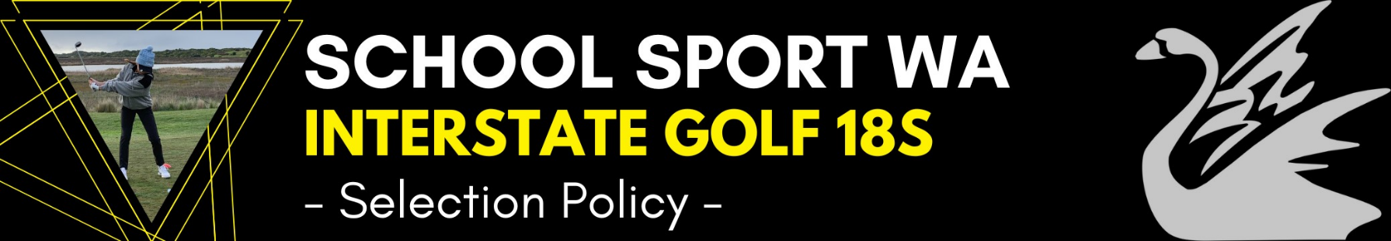
Last Updated:
Dec 2023
Event Details
- School Sport WA (SSWA) participates in the School Sport Australia (SSA) Golf Championship for students 18 years and under.
Eligibility
- Students must be 18 years of age or under as at 31st of December in the year of competition
- Students must have a recognised Golf handicap and play regularly in competitions.
- Students must be a full time student at a recognised Department of Education institution
Selectors
- The positions of Manager and Tour Leader are advertised bi-annually
- Appointed officials will be selectors
The Selection Panel will assess athletes on the following data, competencies, and attributes (but not limited to):
Data:
- GolfWA Crunch&Sip Junior Stroke Averages
- GolfWA Men’s and Women’s State Rankings
- Golf Australia National Junior Order of Merit
- Golf WA Senior Pennant Record
Playing Competencies:
- Student possesses sound technical ability.
- Student demonstrates appropriate course management.
- Achievement and maintenance of fitness requirements for this level of competition.
Personal Attributes:
- Student can overcome adversity and adapt to the surroundings/circumstance.
- Student communicates positively and is open to receiving feedback.
- Student is dedicated to the process of reaching their full potential on and off the golf course.
Nomination
- Players are to nominate for Interstate Team Selection completing an online nomination form. This is forwarded automatically to the Sports Coordinator and SSWA.
- Successful players are notified at the completion of the selection process when a final team plus reserves is named and invited to attend a Parent Information Session.
- Selectors may replace team members at their discretion should they be ruled out prior to the championship for any reason.
18 & Under Medal Winner Policy
One Medal Winner from the Boy’s team and one from the Girl’s team will be selected based on:
- 25% Individual results
- 50% Matchplay results
- 25% Demonstrated team spirit and attitude. (This judgement will be made by both Managers and the Tour leader in collaboration).

