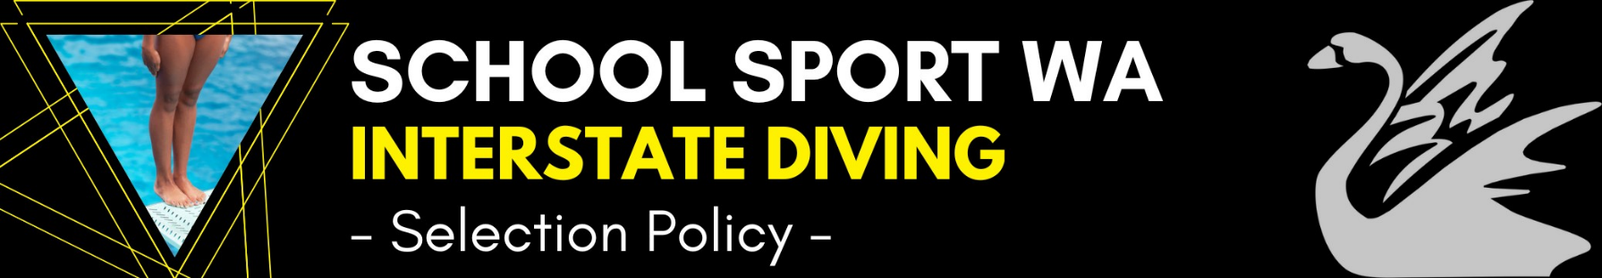
Last Updated:
2022
Team Selectors
Panel to consist of: Diving Coach/es and up to 2 others appointed by Diving WA. The Coach is to be the Chairperson.
Prior to Team Selection
- Selectors meet to discuss team selection criteria.
- Team selection criteria as listed will be adhered to in all cases except where exceptional circumstances may prevail.
Trial Events
Students will be required to nominate for team selection via the online form on the SSWA website by the required date. This web page will redirect nominees to the Diving WA website to register for the selection event.
- There will be no cost for nominations.
- The trial event for selection onto this team will be held on (date TBA).
- DWA Event Entry Fees will apply and be published when registrations open
- Students will be required to participate in either of the following two events on these dates to be considered for selection:
Selection Process
Prospective team members must complete and submit the official online nomination form by the required date.
- Late nominations, due to exceptional circumstances, may be considered but not necessarily accepted.
- Prospective team members must enter and compete in all events they nominate for at the Trial events to be considered.
- Students that are unable to compete due to exceptional circumstances may be considered, but not necessarily accepted, based on their most recent State, National or other Qualification Event.
- Team selection will be based on selecting up to 3 divers per event in each age group and sex, as per the published rules for the 2020 School Sport Australia Championships.
- The first placed diver in each event of the trial will gain automatic selection onto the team.
- The remaining positions will then be selected from the nominated divers at the discretion of the selectors; based on performances at the trial and with the purpose of maximising the opportunities within the team.
- If any positions on the team remain unfilled or become vacant at any time (due to withdrawals etc), the selectors may use their discretion to select alternative suitable divers to fill those spaces.
- Team membership will be confirmed (date TBA), providing all necessary procedures have been completed.
After Team Selection
Team members will be required to adhere to all SSWA Policies and Processes with regard to team preparation and presentation including attendance at all compulsory team meetings.
Medal Winner Policy
12s
- Athlete deemed to have displayed perseverance, commitment and team spirit, as voted by team officials and/or athletes.
Competition Requirements (as per SSA Rules and Guidelines)
Springboard
Age | Event | Limited Dives | Unlimited Dives
10 | 1M and 3M | 2 dives from different groups @ 3.6 | plus 2 dives from different groups unlimited DD
11 | 1M and 3M | 2 dives from different groups @ 3.6 | plus 2 dives from different groups unlimited DD
12 | 1M and 3M | 3 dives from different groups @ 5.4 | plus 2 dives from different groups unlimited DD
13 | 1M and 3M | 3 dives from different groups @ 5.4 | plus 2 dives from different groups unlimited DD
14 | 1M and 3M | 3 dives from different groups @ 5.4 | plus 3 dives from different groups unlimited DD
15 | 1M and 3M | 4 dives from different groups @ 7.6 | plus 3 dives from different groups unlimited DD
16 | 1M and 3M | 4 dives from different groups @ 7.6 | plus 4 dives from different groups unlimited DD
17-19 | 1M and 3M | 5 dives from different groups @ 9. | plus 4 dives from different groups unlimited DD

Platform
Age | Event | Limited Dives | Unlimited Dives
10-12 | 5M only | 2 dives from different groups @ 3.6 | plus 2 dives from different groups unlimited DD
13-14 | 5M/7.5M | 3 dives from different groups @ 5.4 | plus 2 dives from different groups unlimited DD
15-16 | 5M/7.5M/10M | 3 dives from different groups @ 5.5 | plus 3 dives from different groups unlimited DD
17-19 | 5M/7.5M/10M | 4 dives from different groups @7.6 | plus 3 dives from different groups unlimited DD

