Last Updated:
Nov 2023
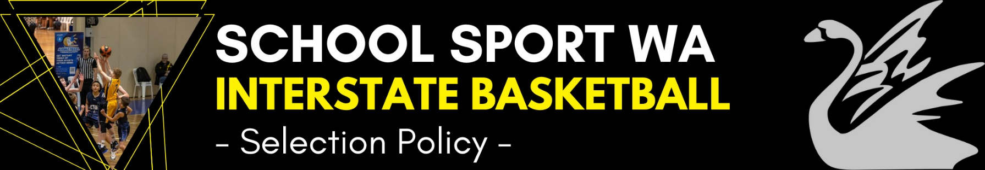
CHAMPIONSHIP DETAILS
- School Sport WA (SSWA) participates in the School Sport Australia Combined Basketball Championships for 16 years and under and 12 years & under students.
ELIGIBILITY
- 12 Years & Under – All players will turn 11 or 12 years of age in the year of competition. Students who turn 11 in the year of competition and who are selected in the final team must be accompanied to the event by a parent or nominated guardian and be accommodated with that parent or guardian.
- Eligible player ages will be determined as at the 31 December in the year of competition.
- Please note that 12 years and under is known as Under 13’s for BWA / BA competitions.
- Please note that 16 years and under is known as Under 17’s for BWA / BA competitions.
- Students eligible for selection in the state team must attend schools or Department of Education recognised educational institutions.
SELECTORS
- The positions of Coach, Manager and Tour Leader are advertised annually.
- Appointed officials will be selectors.
PRIOR TO SELECTION TRIALS
- Selectors meet to discuss selection criteria.
- Selectors may potentially view players through Basketball WA events, school games and any other basketball activities.
TRIAL NOMINATIONS
- Trial dates are determined by officials and SSWA.
- Details and nomination form are posted on the SSWA website.
- Basketball WA distributes information to all affiliated clubs advertising trial information.
- Once students have nominated for the trials, there will be no further confirmation from SSWA regarding attending the trials on the nominated trial dates (unless the dates have had to be changed at the last minute).
- Students and parents are responsible for noting the dates and times of the trials that the student has nominated for and ensuring attendance at the trials on the day.
- Any questions relating to the trials can be addressed to the Basketball Sports Coordinator at School Sport WA.
PRE TRIAL
- Nominations to be completed online. They will be collated by the SSWA Basketball Sports Coordinator and handed to team managers at the trial.
- List of nominees is cross matched with attendance at the trial.
SELECTION TRIALS
- Trials are conducted at a nominated venue, supervised by coaches, assistant coaches, managers and nominated selectors.
- Selectors view players through a series of drills and game situations.
- A train on squad is selected.
- Successful players are notified as soon after the completion of the trial as practicable.
- Players injured or unable to attend the trial will not necessarily be omitted from the final team and may be invited by selectors to attend trials or squad training sessions at later dates.
SQUAD TRAINING
- After a set number of training sessions, during which cuts to the squad size will be made, the final team is announced.
- A number of players may be invited to ‘train on’ as potential reserve players.
SELECTION POLICIES
- Selectors may advise players that certain squad training dates can be missed due to injury, travel or special commitments.
- Players with school or Basketball WA commitments, and who have completed the required SSWA nomination process, may be included in squads after the initial trials, as their commitments are completed.
- Athletes who are in the Basketball WA Under 13 Future Development Program (FDP), and have completed the required SSWA nomination process, are not required to attend the initial trial.
- Should any player be ruled out prior to the Championship for any reason then a replacement player may be selected from the ‘train on’ group (dependent on team requirements).
MEDAL WINNER POLICIES
12 years and under
- Player deemed to have displayed perseverance, commitment and team spirit, as voted by team officials and/or players.
16 years and under
- Coaching staff vote after each game 3-2-1. Medal winner will be decided from this.
- Separate players MVP – Players vote 3-2-1 after each game.

