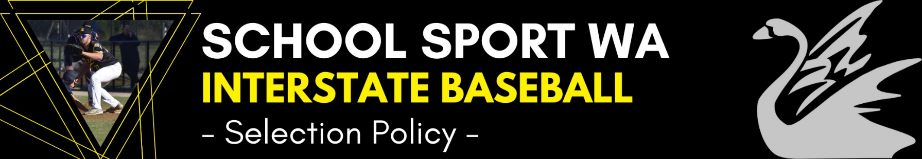
Last Updated:
2022
Selectors
- The positions of Coach, Manager and Tour Manager and Sports Trainer (if required) are advertised annually.
- A representative from Baseball WA will be selected by Baseball WA annually.
- The Coach, Assistant Coaches and Manager will be responsible for the selection of the team.
- Member of the coaching staff will be present for the trials held by Baseball WA.
- Discussions with the Baseball WA U16 and U18 Head Coaches may be undertaken to discuss a player’s performance and behaviours at both the trials and the National Championships if selected.
Trial Nominations
- Trial dates are determined by the Baseball Committee consisting of Coaches and Tour / Team Manager
- Details and nomination form are posted on the SSWA Website
- Team manager will post all details on the Baseball WA website (subject to their approval) advising them of upcoming trial dates and invites schools and individuals to nominate for trial on the SSWA website.
Pre Trial
- Nominees are informed of trial date and time by team manager
- Any other relevant information will be posted on the SSWA Interstate Baseball specific Facebook page.
Selection Trials
- Trials are held at a nominated location(s).
- Trials will be held over multiple sessions.
- Selectors are allocated duties on the day by the Head Coach
- The selection trials will be held in conjunction with Baseball WA’s National teams trial days. For those players who are not trialling as part of the Baseball WA’s National team, a single trial session will be held.
- Selections will be based on performance at the trials and the National Championship performances.
- Successful trialists are notified on the Internet (SSWA and BWA websites) after the trial at a date to be determined and given to trialists.
- Players who cannot attend the nominated trial dates will need to inform the Team Manager where alternative arrangements, if required will be made.
Squad Training
- After the trials are finished, the final team is announced and a number of boys (usually 2~3) are invited to continue training with the team in a “train-on” [emergency player] capacity.
- Players whose charter makes the Australian Championships in the Senior and Junior League may need to withdraw from the selected squad.
- Due to the specialist nature of baseball, a player who needs to be replaced may not necessarily come from the train-on players or players who trialled.
- Players are expected to be at all training. If a player misses multiple training sessions for reasons considered to be unacceptable, they may be withdrawn from the squad.
- Players who have a bona fide reason for not trialling, may still be selected in the team if they are available for the Championship.
Selection Policies
Players injured during the trial process will not necessarily be omitted from the final team and may be invited by the Selectors to attend trials or squad training at later dates.

