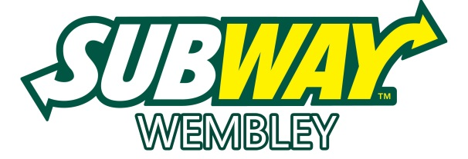
Location:
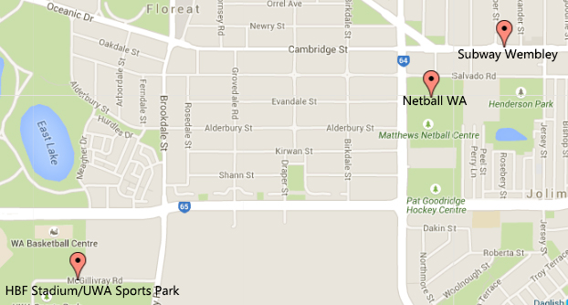Address: 350 Cambridge Street, Wembley.
We are a 1 minute drive from Netball WA and just a 5 minute drive from HBF Stadium/UWA Sports Park.
Pricing: (COUNTRY WEEK,2023)
Subway Platter A (5 Footlong subs/15 portions) | $56
Subway Platter B (7 Footlong subs/21 portions) | $78
Cookie Platter (36 Cookies) | $30
Coca Cola 600mL / Mount Franklin 600mL | $3.50

Contact:
Phone: 0466 491 608 or 9285 8688 (Azlan)
E-mail: subwaywembley@gmail.com

