
SCHOOL SPORT WA
THE 16th GIRLS
PRIMARY FOOTBALL CHAMPIONSHIPS
2023

COACH COMPETITION RULES AND INFORMATION

REGIONAL CHAMPIONSHIPS

AND STATE CHAMPIONSHIP

THE GIRLS
CHAMPIONS CUP

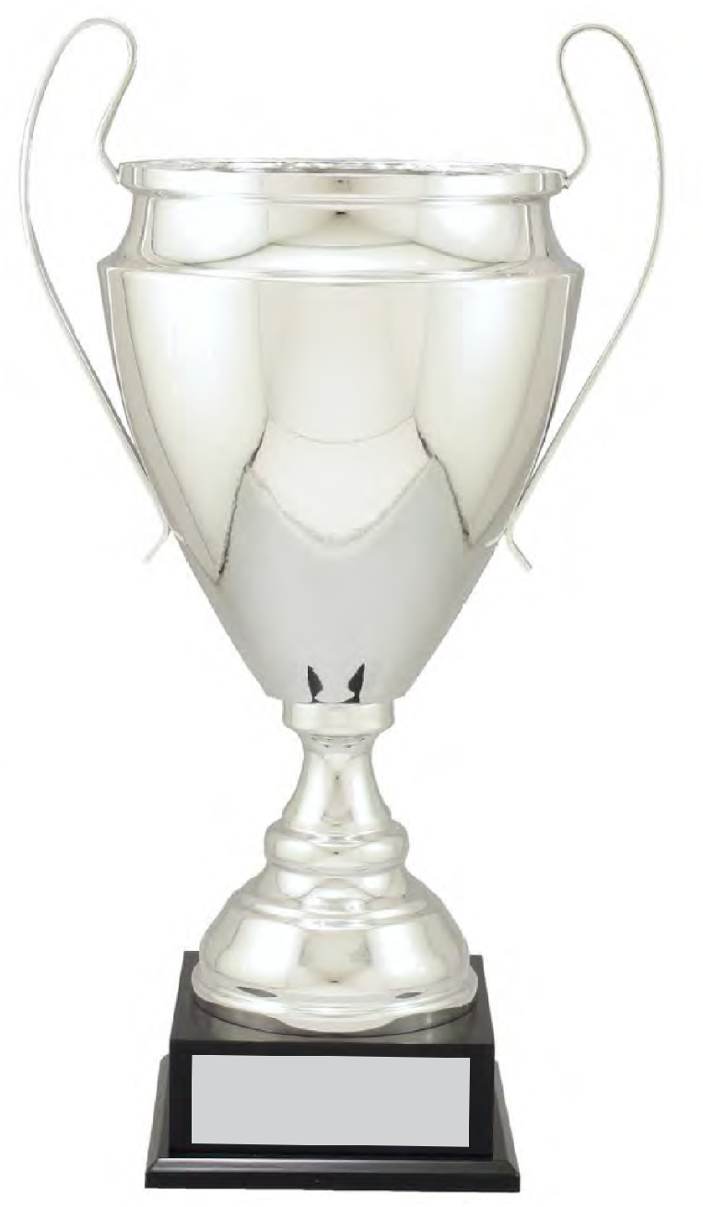

Thank you to our Sponsors:



The Girls Champions Cup’s focus is on girls being able to participate in a friendly, healthy, organised environment, and the developing of fair play and life skills.

COMPETITION RULES AND INFORMATION

PLEASE NOTE: All games will be 9 a side on half a senior sized pitch.

These Rules are subject to change from time to time by School Sports WA. All such alterations shall be made prior to the commencement of the Championships.
- School Sports WA shall conduct the Championships each year for students in Years 3, 4, 5 and 6 girls only.

- The Southern, Northern and Eastern Regional Championships will be will run on various dates depending on ground availability. Confirmed dates will be provided in the School Sport WA website and Contact Details sent out to schools with all other relevant information,

- The State Championship Finals, (Qualifying Finals, Semi Finals and State Grand Final) between the Champions and Runners-Up of the 4 Regional Championships will be held on Friday, 19th May 2023

- PLEASE NOTE: THE CHAMPIONS AND RUNNERS-UP FROM EACH REGION WILL BE INVITED TO THE STATE CHAMPIONSHIPS UNLESS OTHERWISE ADVISED.

REGIONAL CHAMPIONSHIPS

- Thank you to George Golub One Agency South Real Estate for their sponsorship in 2022. The funds will assist in the purchasing of necessary equipment that constantly needs replacing, and is used for the Regional and State Championships to run effectively. This assistance is greatly appreciated.

- Regions may consist of between 4, 5, 6, 7, 8, 9, 10, 11or 12 school teams. Regions with 4, 5, 6 or 7 teams will have a round-robin competition. With the team with most points being named Champions. The regions with 8, 10, 11 and 12 teams will be placed into two groups where they will play qualifying group games culminating in a Regional Grand Final played on the same day.

- The Regional MVP will be selected by the referees if solely a round robin championships. Points will be collated at the end of all the games. The player with most points will win the award. If the Championship is decided in a Grand Final, the referee will select the MVP from the Grand Final.

- The Dave Whalley Goalkeeping Golden Gloves Medal will be presented to the Most Valuable Goalkeeper at each Regional Championship.

- If a school has 2 or more teams in the Regional Championships, players must not move from one team to the other. Once the Regional Championships starts squads must stay unchanged. If this does occur, the transgression will result in the forfeiting of points for the game/s affected, with the opposing team receiving 3 points and a score of 3 goals to nil. If a team or teams from a school reach the State Championships schools can select players as they wish for these teams.

- The Regional Grand Final winners will receive:

- Individual winners’ medals to a maximum of 14 per team. (Sponsored by TBC)
- Championship Cup for the winning schools to keep. (sponsored by TBC)
- The Regional Grand Final Runners –up, will receive individual medallions, to a maximum of 14 per team. (Sponsored by TBC)

- Armando’s Intersport will be sponsoring the Regional Team Fair Play Award for the most sporting school. The school will receive a plaque to recognise the award. The Fair Play Award is presented to a player in the State Championships.

Award Criteria:
- Team plays with respect for each other, the opposition, the officials and the spectators.
- Team always acts in a friendly manner off and on the field with their designated area always kept neat and tidy throughout the day.
- The Coach allows the players to play with freedom and positivity.
- School spectators are positive and encouraging towards their school and all others.

- The Most Valuable Player medal is given for each Grand Final or round-robin champion, including a ball. The ball is sponsored by Onside Sports.

- All participating students will receive a participation certificate.

- The Regional Championships shall be decided by points earned during the teams’ respective group/round-robin stage.

a) Three points shall be awarded for a win, one for a draw and no points for a loss.

b) In the event of teams finishing the with equal points, the team with the greatest goal
difference (total goals scored minus total goals conceded) shall be the winner of the group.

c) In the event that points and goal difference are equal, the team scoring the higher number of goals in the group stage shall be the winner.

d) Where the results of 3(b) and 3(c) are equal, the team with the best results between the two teams concerned shall be the winner.

e) Where the results of 3(b), 3(c) and 3(d) are equal, the winner shall be determined by either the toss of a coin or a penalty shoot-out, at the discretion of the Championships’ Coordinator at the venue where the situation arises.

- In the event of forfeiting a match, that match result and three goals will be awarded to the opposing
team.

- Duration of matches: 12-minute halves (7 teams in a region), 15 minutes (5 or 6 teams in a Region) or 20 minutes (4 teams in a Region), 5 minutes for half time breaks and between10 and 15 minutes between matches depending on the number of teams in the Region.

- Matches must start on time. If teams are not in position by the designated start time the game time will still commence. An air horn will be sounded, to ensure all each half of all games start and end at the same time.

- The ball size shall be a size 4. Onside Sports, is the official SELECT ball sponsor.

- PLEASE NOTE: Due to Football West not providing sponsorship to cover the payment of official referees, the Organising Committee has coordinated with the Football Academy Schools to provide students who are training to become referees to officiate in the Regional Championships. These students are from John Curtin College of the Arts, Lynwood Senior High School and Woodvale Secondary College. They will also be providing Assistant referees.

- The State Finals will have 4 referees to ensure the quality of the competition is upheld to a high level. (Football West will not supply official referees.) The referees may be students from John Curtin College of the Arts or Woodvale SHS Football Programs or experienced referees, if available.

- Lynwood, John Curtin, and Woodvale will be using the Championships to identify talent for their respective elite football programs.

- Where there is a clash of colours the first-mentioned team will be required to change. A set of bibs is provided, if required. It is suggested that each school brings their own set of bibs to wear over school playing shirts as a simple solution, just in case there is more than 1 team with clashing colours. Covid-19 is also a good reason to ensure that each school has their own bibs.

- The referees will be using match cards as official records of goals scored and points won. They will be collected immediately after the match and taken to the recording official.

- Note: A match result cannot be changed once the game is completed. If coaches have any concerns the coordinator must be approached before this occurs. At no time is the referee to be approached or criticised by a coach, player or parent. The Coordinator is the only person to be approached to address issues or concerns.

- A MAXIMUM OF 14 PLAYERS ARE ALLOWED IN EACH SQUAD. If more than 14 players are used, the transgression may result in the forfeiting of points for the game/s affected, with the opposing team receiving 3 points and a score of 3 goals to nil.

- The players may be from Year 3 to 6 girls.

- The interchange area will be at the halfway line. The interchange of players will only be permitted through this area. The player being replaced must leave the playing area before the substitute can enter the playing area.

- All substitutes are permitted to be used in each match. There are no limits in changes.

- Please read the 9 a-side rules provided.

- All players must wear shin pads during games. This is an important duty of care issue. Schools must supply them if students do not have their own. Referees will not allow students to play without shin pads.

STATE CHAMPIONSHIPS

- Schools who win the Regional Championships and had 2 teams participating may select their strongest team from the 2 squads for the State Championship.

- If a school has 2 successful teams in the Regional Championships they will both be allowed to participate in the State Championships but will be fixtured to play each other in the first round of the Championships.

- The schools that win through to the State Championships need to email a list of players, coaches’ names and a jpg of the school emblem to Tony immediately after the Regional Championships for inclusion in the girls’ State Championship program. A TEAM PHOTO FROM THE REGIONALS IS ALSO REQUIRED.

- The Champions and Runners-Up of the South, Northern and Eastern Regional Championships will play in the State Championship Qualifying Finals and Grand Final at:

- Aubin Grove Community Oval, Camden Boulevard, Aubin Grove
- On Friday 19th May 2023.

- Game Times:

- The Qualifying Finals will commence at approximately 4:45 pm.
- The Qualifying Finals will consist of 2x20 minute halves. If the game ends in a draw, a penalty shoot-out will decide the Semi Finalists. There will be no extra time.

- The First and Second Semi Final will commence approximately 15 minutes after the Quarter Finals at approximately 5:45pm.
- The First and Second Semi Final will consist of 2x20 minute halves. If the game ends in a draw, a penalty shoot-out will decide the Semi Finalists. There will be no extra time.

- The Tanya Oxtoby State Championship Grand Final commences at approximately 15 minutes after the semi-finals at approximately 6:45 pm.
- The game will be played under lights.
- The Grand Final will consist of 2x20 minute halves. If it is a draw at the end of the normal time, 2x5 minutes of extra time will be played. If the scores are still tied at the end of extra time, penalties will decide the winners.

- Referees and referees’ assistants will officiate (if available) in all games. There will be 4 referees officiating (if available) in the State Grand Final.

- Everyone is welcome to come and enjoy what will be an exciting evening of Primary School Football.

  - Aubin Grove United Clubs’ canteen will be opened for all spectators and families. Please support the club as they are allowing us the use of their facilities at no cost.

- The winners and runners –up of the State Championship Grand Final will receive:

- individual School Sport WA medallions for the players (sponsored by Rigsafe Lifting Solutions)
- The Ron Addison Medal for the Grand Final Coaches (sponsored by Rigsafe Lifting Solutions)
- The Champions school will receive the Tanya Oxtoby State Championships Cup (sponsored by The World of Plaster) to keep and
- the Perpetual Girls Champions Cup will also be presented to the Champions.
- The Marianna Tabain Medal (MVP of the Grand Final) will also receive a SELECT ball sponsored by Onside Sports.
- The Dave Whalley Goalkeeping Golden Gloves Medal (Most Valuable Goalkeeper of the State Championship, sponsored by Dave Whalley Goalkeeping)
- George Golub One Agency South Sponsorship will assist with referee payments.

- Constructive suggestions to improve and further develop the Championships and Primary School Football, in the coming years are greatly appreciated. All your suggestions are taken seriously and acted upon by the Organising Committee.

- Anyone interested in being involved in 2023 in the Organising Committee or assist in sponsoring the Championships so more children can play the game and enjoy playing in a wonderful team environment, should contact Tony Carvajal on:

  - Mobile:0450 742 636 or email: tonylcarvajal@gmail.com

SCHOOL SPORTS WA, GEORGE GOLUB ONE AGENCY SOUTH, THE WORLD OF PLASTER, RIGSAFE LIFTING SOLUTIONS, ONSIDE SPORTS, ARMANDO’S INTERSPORT AND DAVE WHALLEY GOALKEEPING WELCOME ALL PARTICIPATING SCHOOLS TO THE 2022 CHAMPIONSHIP.
The Organising Committee
Thank you to our sponsors:

Welcome to George Golub One Agency South in 2022

World of Plaster provides the Regionals and State Championship Cups

Rigsafe Lifting Solutions provides the medals for the State Championships.

Onside Sports provides SELECT balls for the Championships.

Armando’s Intersport provides the Fair Play Awards

Dave Whalley Goalkeeping provides the Golden Glove Medals




The School Sport WA Primary Schools Champions Cup’s focus is on children being able to participate in a friendly, healthy, organised environment, and the developing of fair play and life skills.

The School Sport WA
Primary Schools
Girls Champions Cup
Regional and State Football Championships
proudly supports the:

Children’s Leukaemia and Cancer Research Foundation
Please Note:
As a way to raise awareness and some funds for the Children’s Leukaemia Cancer Research Foundation, it would be a wonderful symbolic gesture for all the participating students to donate a gold coin to this important Foundation. Official tins will be provided at all venues for all students and spectators who wish to contribute. It is not compulsory for anyone to contribute. It is purely voluntary; however, your support would be greatly appreciated.

