Long Jump 2

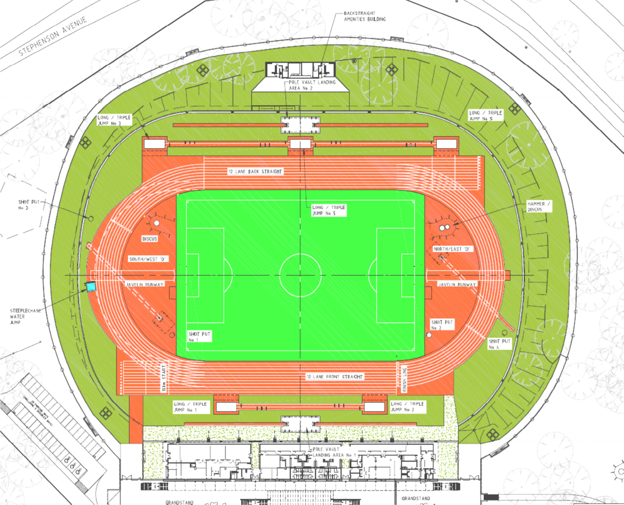

Shot Put North

Shot Put South

Triple Jump Pit 2

Triple Jump Pit 1

Long Jump 3

Long Jump 1

Long Jump 4

HJ Pit North

200m Start & Marshaling

Computer Recording Room in Grandstand

Medical Post

HJ Pit South

Discus North

Discus South

1500m Marshaling

400, 800, 1500 record tent

100 & Hurdles Marshaling Area