— AFL 15s BOYS RESULTS & HISTORY 1929 —
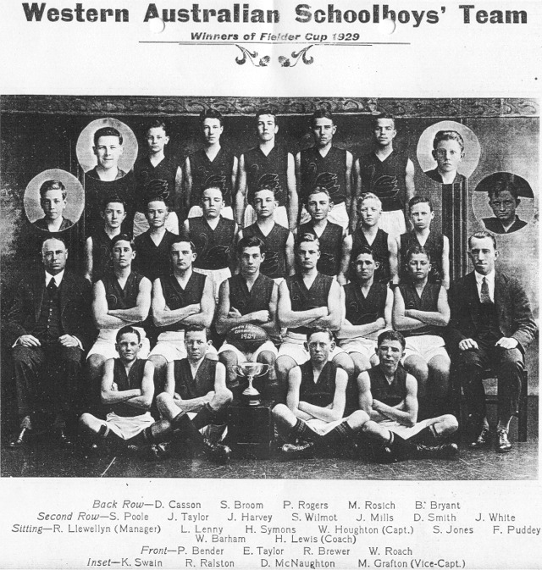

CHAMPIONSHIP DETAILS
DATE | VENUE | OVERALL RESULT
 | Perth, WA | 1

COACH | MANAGER
H Lewis | R Llewellyn

PLAYERS
FIRST NAME | SURNAME | SCHOOL
W | Barham | Claremont School
P | Bender | Highgate School
R | Brewer | Perth Boys School
S | Broom | Kalgoorlie
B | Bryant | Fremantle Boys School
D | Casson | Claremont School
M | Grafton (VC) | Northam School
J | Harvey | Fremantle Boys School
W | Houghton (C) | Fremantle Boys School
S | Jones | Perth Boys School
L | Lenny | Perth Boys School
D | McNaughton | Technical School
J | Mills | Fremantle Boys School
S | Poole | Fremantle Boys School
F | Puddey | Thomas-Street School
R | Ralston | North Perth School
W | Roach | Fremantle Boys School
P | Rogers | Perth Boys School
M | Rosich | Perth Boys School
D | Smith | Fremantle Boys School
K | Swain * | Perth Boys School
H | Symonds | Technical School
E | Taylor | Technical School
J | Taylor | Technical School
J | White | Technical School
S | Wilmot | Perth Boys School
(C) Captain (VC) Vice Captain (MW) Medal Winner (*) All Australian

