— AFL 15s BOYS RESULTS & HISTORY 1949 —

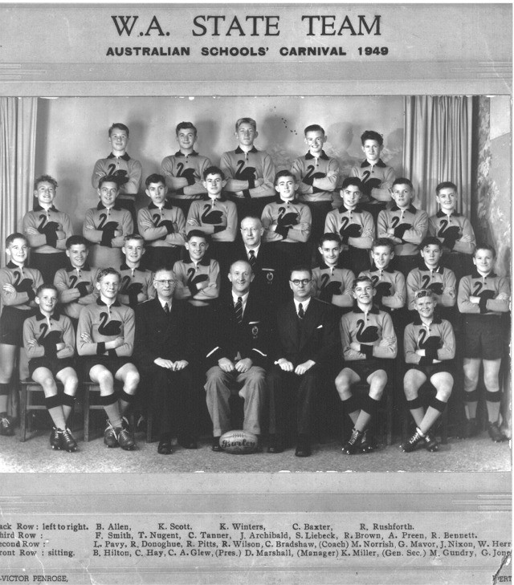

# CHAMPIONSHIP DETAILS

|  |  |  |
| --- | --- | --- |
| DATE | VENUE | OVERALL RESULT |
|  | Adelaide, SA |  |

|  |  |  |  |
| --- | --- | --- | --- |
| COACH | MANAGER | PRESIDENT | SECRETARY |
| C Bradshaw | D Marshall | Charlie Glew | Ken Miller |

PLAYERS

|  |  |  |
| --- | --- | --- |
| FIRST NAME | SURNAME | SCHOOL |
| B | Allen | Fremantle Boys High School |
| J (Des) | Archibald | Harvey Junior High School |
| Craig | Baxter | Cunderdin |
| Ron | Bennett | Perth Boys High School |

|  |  |  |
| --- | --- | --- |
| Ray | Brown | Quairading State School |
| R | Donoghue | Forrest Street |
| Max | Gundry (C) | Midland |
| G | Gray | Forrest Street |
| Colin | Hay (VC) | Perth Boys High School |
| W (Billy) | Herron | Perth Boys High School |
| B | Hilton | Fremantle Boys High School |
| G | Jones | Pinjarra |
| S | Liebeck | Mount Barker High School |
| George | Mavor | Fremantle Boys High School |
| J | Nixon | Fremantle Boys High School |
| Max | Norris | Kent St |
| T | Nugent | Geraldton |
| Len | Pavy | Perth Boys High School |
| Reuben | Pitts | Fremantle Boys High School |
| Alan | Preen | Fremantle Boys High School |
| Ron | Rushforth | Perth Junior Technical School |
| Ken | Scott | Forrest Street |
| F | Smith | South Kalgoorlie |
| C | Tanner | Katanning |
| Ron | Wilson | Perth Boys High School |
| Ken | Winters | Claremont |

(C) Captain (VC) Vice Captain (MW) Medal Winner (*) All Australian