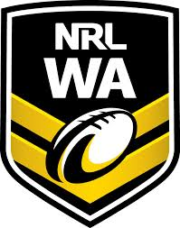
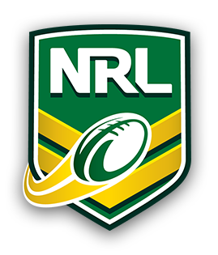
NRL Legends Cup Rules
Field Dimensions: 70 metres x 40 metres
Players on field: 8 players per side
A Try = 1 point

RULE REFEREE ACTION

Forward passing Play the ball to opposing team.

Knock-on Play the ball to opposing team.

Knock back Play on.

Player leaves the field of play Play the ball to the opposing while in possession of the ball team 5 metres in from where the player left the field.

Not back 5 metres in defence Penalty tap to attacking team.

Defensive player moves forward Penalty tap to attacking team.
before dummy half runs or first
receiver catches or runs with the ball

When attacking team has a Play the ball to opposing team
total of six tackles where the sixth tackle is made. completed.

If dummy-half or first receiver gets tackled Play the ball to the opposing
with the ball team

Restart of the game after a try The try scoring team will kick the play ball from the center of the field.

Shepherding / obstruction Penalty tap to opposing team.

Tackled within 5 metres of the Play the ball 5 metres out from try line line

PLEASE NOTE – RULE OUTLINED BELOW
- Please note: Dummy half and/or 1st receiver may run with the ball. The defence may move up when the dummy half runs, or when the 1st receiver catches or runs with the ball. However, if the dummy half or 1st receiver is ‘tackled’, a change of possession will occur. DUMMY HALF CANNOT SCORE A TRY WITHOUT PASSING THE BALL. 1ST RECEIVER CAN SCORE A TRY.
- Kicks: can be above the player’s head, however you must not place any ‘pressure’ on the catcher. Kicks must be picked up by the attacking team before the try-line, then carried over the try-line and placed down to score a try.

